# Document Table

Contents

Document Table 1

GROCARY 2

FRAMEWORK 3

Logging 6

Troubleshooting 8

IP TELEPHONY 8

SIP 11

SIP Servers 13

ROUTING 16

INSTALL URS 17

Options 17

Types of routing 19

Sample Interaction Flow, Enterprise Routing 24

Inbound Voice Routing Architecture with IRD: 27

There are two ways how URS can connect to a database when using Interaction Routing Designer: 27

Load Distribution Server 29

Interaction Flow: Simple Routing 29

Events 30

Inter-Server Call Control (ISCC) 31

Multi-Site Routing: Messaging 32

Configuring (ISCC) 33

E- Services 39

Servers 42

Security in communication 44

Grocary 45

REPORTING 52

Real-time 52

Historical 55

What is a Genesvs Statistic? 58

ANALITIC 60

# GROCARY

**ACD (automatic call distributor, routing)** - tool that can route calls to individual agents or queues based on preestablished criteria such as the time of day that a caller dials a business. A CTI-based routing engine enables users to quickly adjust routing rules, and the best cloud-based routing engines enable routing rules to be adjusted without any IT assistance.

**Advisory tones** – звуки которые включают клиенту, их цель проинформировать что на линии что то происходит. (занято, ожидание)

**Agent** - cc personnel, who handle customer interactions

**ANI** – Automatic Number Identification

**AA** - Automated Attendant. **Автосекретарь** — устройство для ответа на входящие звонки

**BRI** – Basic Rate Interface  — обеспечивает пользователю предоставление двух [цифровых каналов](https://ru.wikipedia.org/wiki/%D0%9E%D1%81%D0%BD%D0%BE%D0%B2%D0%BD%D0%BE%D0%B9_%D1%86%D0%B8%D1%84%D1%80%D0%BE%D0%B2%D0%BE%D0%B9_%D0%BA%D0%B0%D0%BD%D0%B0%D0%BB) (ОЦК) по 64 [кбит/с](https://ru.wikipedia.org/wiki/%D0%9A%D0%B1%D0%B8%D1%82/%D1%81)  и однополосный канал сигнализации со скоростью передачи данных 16 кбит/с.

**Call accounting** – Компьютерная система, подключенная к телефонной, для сбора и мониторинга инфы о звонках

**Call center** – место для централизирования звонков (инбоунд\оутбоунд)

**Call Control** – signals used to start or setup phone call;

**Contact Center** – multimedia-enabled call center. Chat, Email, website support;  
**CPE** – Customer Premise Equipment

**PSTN** - is the aggregate of the world's circuit-switched telephone networks that are operated by national, regional, or local telephony operators, providing infrastructure and services for public telecommunication. Consists of telephone lines, fiber optic cables, microwave transmission links, cellular networks, all interconnected by switching centers, thus allowing most telephones to communicate with each other.

**Queue** – waiting list;

**VoIP** - The capability of engaging in a voice conversation over the Internet;

**Jitter** – Packets arriving out-of-order;

**CSR** – Customer Service Representative;

**CTI** – Computer Telephony Integration; interaction of computers and telephone networks

**DNIS** – номер, который набирает клиент

**DID** – Direct Inward Dialing – direct calls without use of operator;

**DSP** – Digital Signal Processor;

**DTMF** – Dual-tone multifrequency;

**ISDN** – Integrated Services Digital Network; сombines telephone services and data exchange.

**IVR** – Interactive Voice Response; Used in pair with DNMF. Voice message with collect digits.

**NIC** – Network Interface Card;

**Media Gateways** - interface between a legacy and VoIP network. It receives TDM voice signals from the PSTN side: or converts voice signals to digital if the received voice signal is analog: packetizes and compresses them, and transmits the packets over the IP network.

**Predictive Dialer** – Call passed to agent/operator if the call is answered.

**Preview Dialing** - Allows onscreen preview of the number being dialed prior to the actual dialing process;

**PRI –** Primary Rate Interface (E1/T1);

**PBX** (Private Branch Exchange) is a system that connects telephone extensions to PSTN and provides internal communication for a business. An IP PBX is a PBX with Internet Protocol connectivity and may provide additional audio, video, or instant messaging communication utilizing the TCP/IP protocol stack.An IP PBX can exist as a physical hardware device or in software.

**Web Call-Back -** technology wherein the Web visitor fills out a brief form on the Website requesting a telephone call-back at a specific number and specific time to receive needed information.

**Place – actually place** for agent, have one or MORE DN

**Genesis platform**. Platform – set of components for make solution. Consists of:

**Framework –**basis for work of genesys components.

**Routing –** For call routing. Strategyis is used to decide where to route user interaction, using different routing rules

**Reporting –** знает, что происходит в колл центре. Вся инфа о состоянии обьектов в реал тайме, какой агент занят, какой свободен, и т .д.

# FRAMEWORK

**Configuration layer** Responsible for storage, processing, integrity of configuration and disseminate information throw environment. Also for control CC settings through a single entry point. Приложениям дается хост, и порт этого сервера. Таким образом на хостах не нужно хранить конфигурацию. Каждое приложение держит открытым коннект на этот сервер, в случае изменений подтягивает их. Таким образом в реал тайме можно менять опции, но некоторые требуют перезагрузки приложения(написано в гайдах). Если обрывается соеденение к серверу, после восстановления приложение запрашивает изменения с момента разрыва. Также добавляет агенты, хосты и т.д.

Функционал:

-Centralize of config data processing

-Provides a mechanism for the spread of the configuration data so application can receive their config data when started, and also get changes in real-time.

- Реконекшн менеджмент, который следит за тем, что приложения во время подключений будут с актуальными апдейтами.

-Wizards to help users through the automated process of solution deployment.

- Потдержка географически распределенных сред

- Интеграция с внешними источниками данных, с которых можно импортнуть данные в конфигурационную базу.

- Импорт / экспорт в/ из конфиг дата базы.

- Защита данных между компонентами генезис(тлс протокол)

Конфигурационный сервер обеспечивает централизированный доступ к конфиг базе, по ролям, которые суперадминистратор может установить любому пользователю. Его можно поднять в прокси моде, для потдержки географически распределенной среды, все прокси сервера берут инфу из главного.

GA(GAX) имеет доступ к настройкам на этом уровне

**Management Layer** – отвечает за мониторинг и запуск среды (хостов, сервисов) и их управление, логирование, генерация и обработка алармов, управление сбоев приложений.

Функционал:

- Централизированный контроль солюшн, мониторинг, отображение реал – тайм статус любого настроенного обьекта солюшена, включение/отключение солюшн

- Централизированное логирование, логи нужны для траблшутинга.

- Гибкая передача сигналов тревоги , который вызывает тревоги , основанные на событиях технического обслуживания приложений. Сигналы тревоги сообщаться Genesys Администратор и могут быть записаны в системный журнал.

- Фолт – менеджментфункции(определение, изоляция и коррекция падений приложений, автоподьем)

- мониторинг отдельных хостов, включая использование памяти, инфу о сервисах.

- Потдержка удаленного развертывания приложений

LCA расположен на каждом хосте, позволяет слою стартить/ стопить приложения, обноруживать падения, включает GDA

**User interaction layer** –The User Interaction Layer provides centralized web-based functionality and interfaces for the following:

-Deployment of Genesys components to any computer on the network using the Genesys Deployment Agent (a Management Layer component.

-Configuration, monitoring, and control of applications and solutions.

-Currently, Genesys Administrator and its extension is the only component in the User Interaction layer.

Взаимодействет с GDA, CS, SCS, LOG DATABASE

**Media Layer** – позволяет решениям генезис общаться через медиа среду отвечает за интеграцию, отвечает за аттач данные, и всю информацию о звонке, передает информацию агентам, переводит в сип

**Service layer** – собирает информацию с обьектов среды и статистику для его работы, хранить ее(кто сколько ждет в очереди, сколько в среднем и т д)

Преобразование событий, связанных с управлением отдельных взаимодействий в статистических данных , который затем

используется для обработки взаимодействия и отчетности контакт-центра.

**Components**

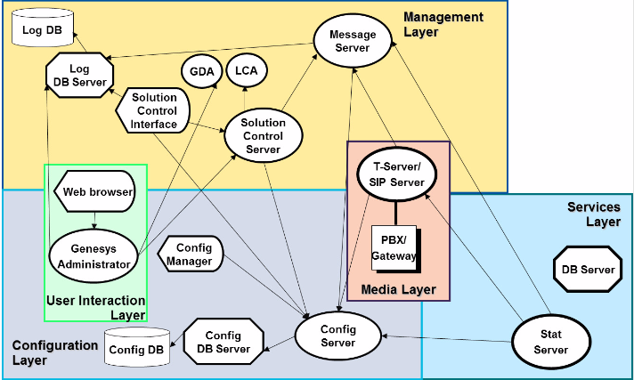

**Configuration layer**

**Config DB** – хранит все конфигурационные данные

**Config DB server** – для связи между сервером и базой данных

**Config server –** контролирует доступ к базе данных через config db server, является его клиентом

**Config manager –** клиент конфиг сервера, предоставляет интерфейс для внесения или обновления конфигурационных данных.

**Wizard manager** - клиент конфиг сервера, интерфейс для внесения или обновления конфигурационных данных.

**Management layer**

**MS-** получает события, логируемые приложениями и ложит их в БД. Клиент **CS, LOG DB Server-a, LCA.** также проверяет наличие журнала событий , настроенных для подачи сигналов тревоги . Если оно обнаруживает совпадение , он посылает сигнал тревоги на Solution Control Server для немедленной обработки.

**SCS –**  Центр обработки. Использует LCA для старта компонентов, мониторит их статус, обеспечивает рестарты или свитчоверы. Так же работает с Т-серверами. может подписаться на события MS и обрабатывать их (например alarm).

**LCA –** интерфейс, ставиться на каждый хост чтобы что то установить, запустить, получить список процессов через командную строку

**GDA –** включен в LCA, **штука**, которую использует GAX через которую устанавливаються приложения remote

**SCI – подключаеться к лог базе, чтобы прочитать логи,** отображает их, старт и стоп компонентов

**LOG DB – бд** логов, записи алармов, аудитные записи.

**Log DB SERVER –** посредник между БД и MS, SCI, клиент CS

**User interaction layer**

**GA –** вэб интерфейс развернутый на вэб-сервере, предоставляет:

- сочитает функции Configuration manager, solution control interface, и других гуи

- функционал для развертывания инсталяционного пакета на любом хосте.

- Контроль доступа по ролям

- Общение c SCS для обмена статусами, контрольной информацией, СS для конфигурационной

- Читает логи из базы логов

**Services layer**

Stat server- держит в себе актуальное состояние колл центра, клиент t/sip сервера, и конфиг сервера

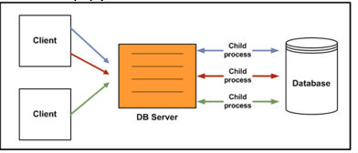D**B server architecture**

# Logging

-**standard** – errors and major events

-**interaction** – provides the details of an interaction processed by the solution components that

handle interactions

-t**race** – extension of standart. Include many minor events (opening connection, add/delet agents, changes of configuration)

-**debug** – detailed actions and data. provides an extremely detailed log of the internal workings of the application. As its name implies, the debug level is used primarily for debugging.

**Logs output**

**stdout or stderr –** sends log messages to standard output or standard error output

**network –** sends log messages to a central log database which combines log records from any number of applications across multiple accessible by a single interface (SCI). **Debug level log events cannot be accommodated by the log database.**

**memory –** sends logs to the memory output on the local disk. Used for application recovery, this output is basically a dump of runtime memory and requires the least amount of application resource

**<filename> –** sends logs to a file.

**Formats – text, xml, DB**

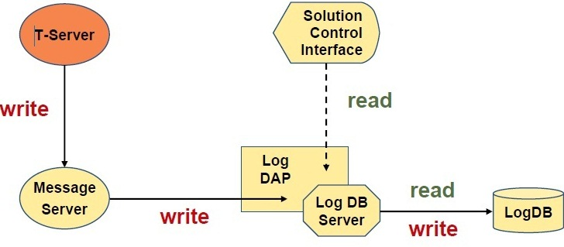**Network logging**

**db_storage** = **true** in the [**messages**] section of **DAP**!!!

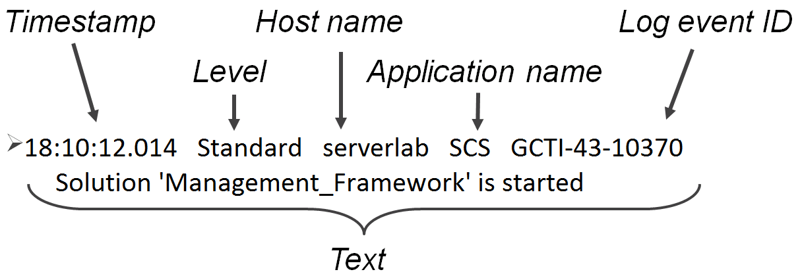

# Troubleshooting

Applications Status

**Stopped**

Indicates that an Applications installed and configured in the system but it has not started

**Pending** - Приложение активируется/деактивируется. В первом случае SCS выполнил команду запуска, но приложение еще не подключилось к LCA на хосте, во втором случае еще не отключилось.

**Initializing -** проходит шаги: запуск, чтение конфиг файлов, проверка. Уже подключено к LCA, но еще не готово для использования.

**Service Unavailiable -** нужно искать проблему. В случае с Т- сервером, его приложение не подключено к CTI.

**Suspending** – приложение получило стоп сигнал. Прекратило принимать запросы, но дорабатывает принятые. Suspended – отработало.

**Unknown** – Management layer не может предоставить\получить инфу. Возм scs не соеденен c LCA. Выполняет ли приложение свои фнукции – неизвестно

**Third Party Application Management** Through Genesys Administrator and/or SCI, you can also manage third-party applications. Aplication **must to be a service, and run as script**!

**Host status**

**Up** Indicates that SCS has successfully connected to the Local Control Agent (LCA) running on the given host and, therefore, can control and monitor all applications located on this host.

**Unavailable** Indicates that SCS cannot connect to the LCA running on the given host or has lost a previously established connection because the host is not started or has failed.

**Unreachable** Indicates that SCS cannot connect to the LCA running on the given host or has lost a previously established connection because of a network connectivity problem between

**Down** • LCA has not started on the given host, has terminated, or has stopped responding.

* LCA is not configured correctly in the Configuration Layer.

**Unknown**

* In a Distributed SCS configuration, the SCS to which Genesys Administrator is connected cannot connect to, or has lost a previously established connection with, another distributed SCS that is assigned to the given host.
* Genesys Administrator cannot connect to, or has lost its connection with, SCS on the given host. In this case, Genesys Administrator will show all hosts with a Unknown status.

# IP TELEPHONY

Voice Over IP Advantages

* + Efficient use of available bandwidth
  + Major cost savings
  + Voice traffic delivered directly to the desktop
  + Integrated Services: voice, voice mail, email, etc
  + More than one call on the same broadband-connected telephone line

Based on the functionality, VoIP protocols can be grouped **into two groups**:

-Signaling protocols(For call set up, call tear down) SIP/h.323

-Media (voice, video, fax) protocols (For transmitting media packets over IP network) **RTP/RTCP**

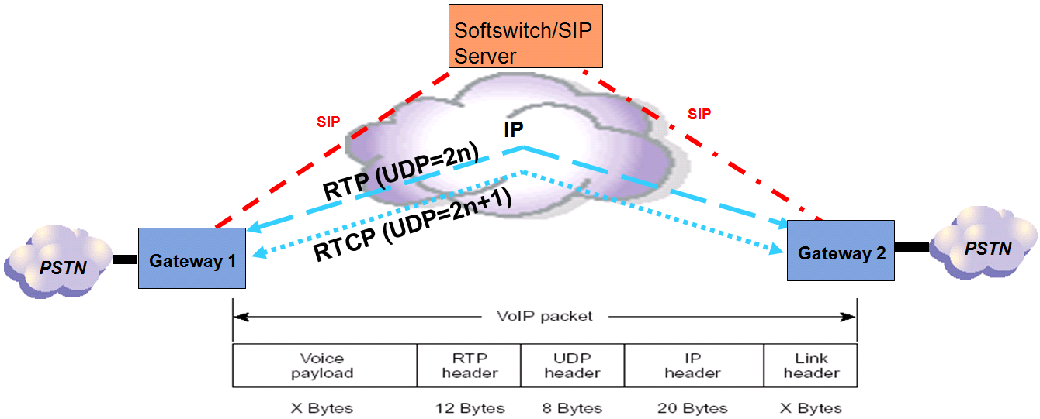RTP – для передачи данных.

TRCP – периодическая подача управляющих пакетов всем участникам сессии

**IP Telephony Network**

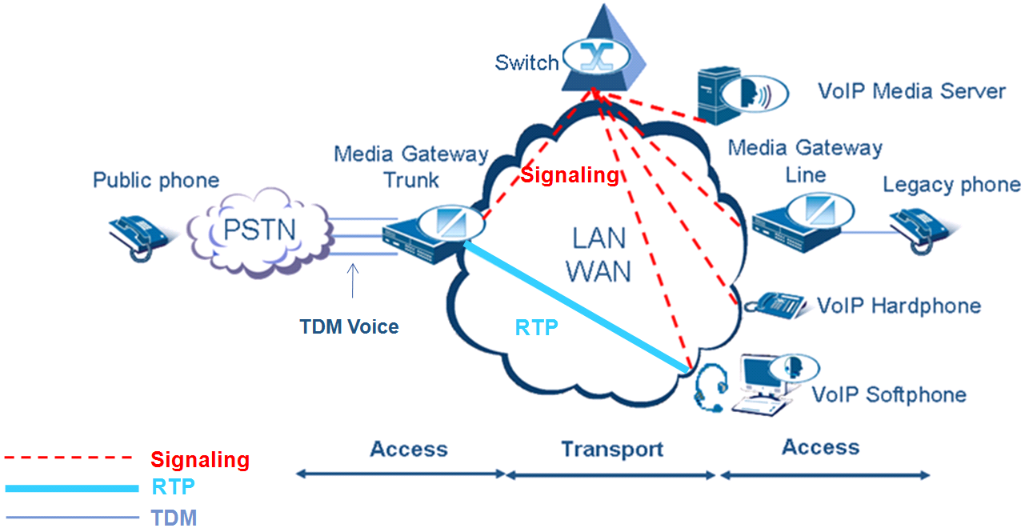

**Media Servers** - process and generate media (voice, video) streams and handle all functions related to tasks such as decoding tones, bridging multiple media streams into a conference, processing scripts, speech recognition, recording audio, etc.

**Switches** - a VoIP switch connects a calling and called party using software running on a computer system.

**Legacy phones** can be connected to a VoIP network through IP Adapters or Line Media Gateways. An IP adapter allows the user to plug in the Ethernet network jack into the adapter and then plug the phone into the adapter. Line Media Gateway converts analog voice signal to voice packets that can be transmitted over the Internet

**VoIP phones**

**Hardphones** - hardware based IP phones. They look and behave just like legacy phones, but they are connected directly to the IP network.

**Softphones** - programs which use a computer's microphone and speakers, or an attached headset to allow users to make or receive calls.

**Softswitch** is a software based switching platform. There are **Pure IP** softswitches that handle only **IP** connections and **Hybrid** switches that can handle both **TDM and IP** connections.

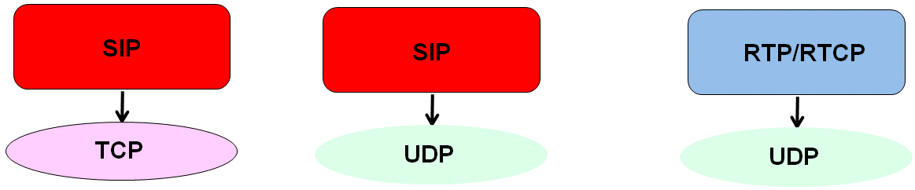

**Quality of Service**

Delays - Typically 150 ms - 180 ms max delay

Packet loss -1% max loss

Jitter - 20 ms or less

Silence suppression

Echo cancellation

Compression/Codecs

**Audio Codecs**

G.711 - Transmission rate 64kbps

G.711 u law, also called PCMU

G.711 a law, also called PCMA

G.729 - Transmission rate 8 kbps.

G.729a -Transmission rate 8 kbps.

G.723.1 - Transmitting a rate 5.3 or 6.3 kbps.

Low rate codecs (low rate codecs = high compression codecs) save bandwidth, but increase delays.

**MOS -** усредненная оценка разборчивости речи. Показатель воспринимаемого качества звука от 1 до 5. Вначале оценивали люди, сейчас программы.

**R-factor** - шкала от 0 до 120, включает ощущения пользователя+ обьективные факторы сети.

Видео кодеки: h621, h263, h264, MPEG, AVC.

Факторы, воздействующие на пропускную способность: Кодеки, период пакетизация, header compression

# SIP

* SIP uses Session Description Protocol (SDP) to describe session parameters

Определяет способ согласования между клиентами о открытии медиаканалов. Протокол уровня приложений

SIP Functionality

* **User Location** - SIP provides the means to determine the address where the user is through a registration process.
* **User Capabilities -** SIP enables determining the media capabilities of each endpoint participating in the call and ensures that the endpoints can communicate with each other if their capabilities are compatible.
* **User Availability** – A user can have several devices registered. If the call is not answered on one of the devices, it is transferred to another device, or to another application such as voicemail.
* **Call Setup** - SIP provides the means to setup communication between the caller and callee.
* **Call Handling-** SIP provides the means to modify the characteristics of the call. A user can also modify a call by making it a conference call or by changing a voice call to a video call if the endpoints have video capability
* **Call Termination** - SIP terminates the call upon user :s request and ensures that even when an endpoint doesn't follow the proper termination procedure, the call resources are released and fee call terminated.

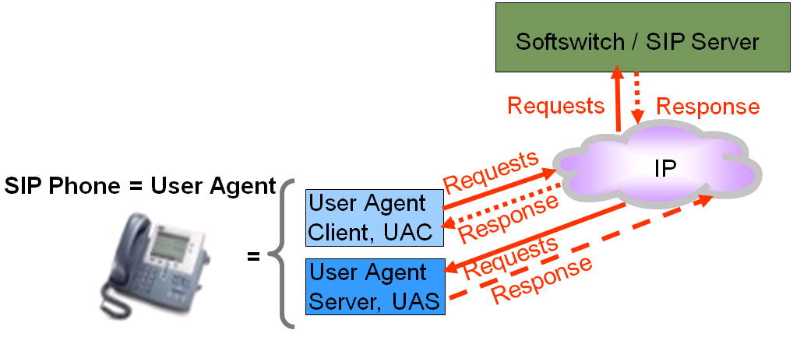A **SIP** request consists of a **method**, a request **URI**, and the **SIP** version

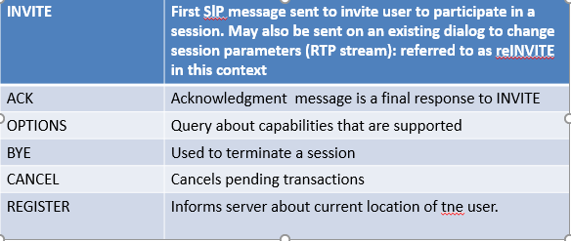

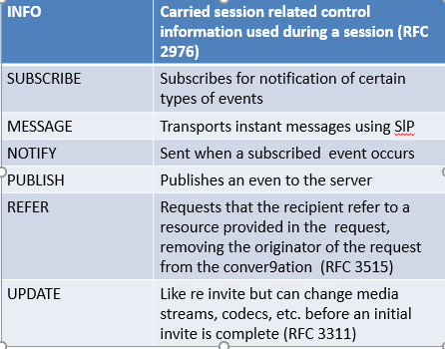

SIP Response Codes

* + 1xx Informational/Provisional
  + 2xx Final
  + 3xx Redirection
  + 4xx Client Error
  + 5xx Server Error
  + 6xx Global Failure
  + 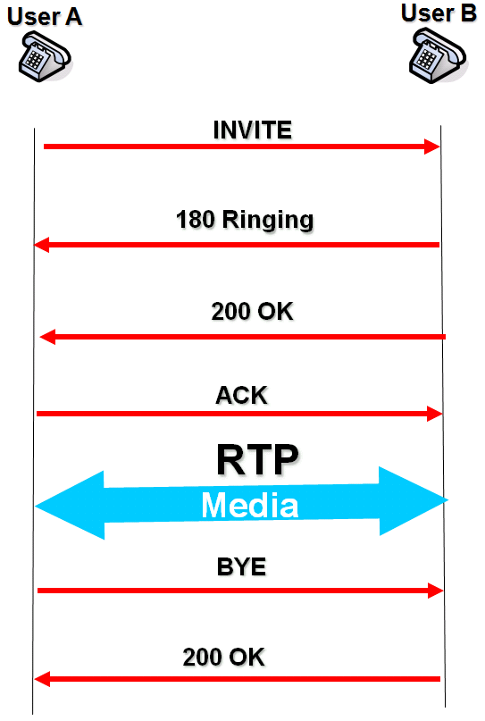

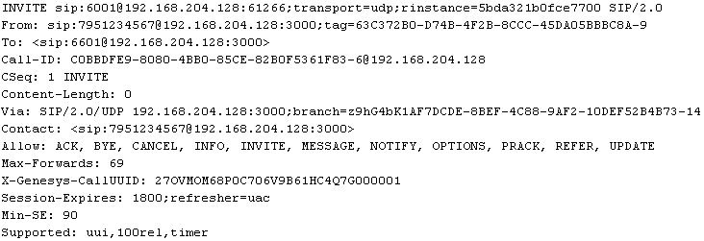

# SIP Servers

SIP Servers are devices located within the IP network whose components can communicate using SIP protocol

The following SIP Servers are defined in RFC 3261:

SIP Proxy Server, SIP Registrar Server, SIP Redirect Server, Back to Back User Agent (B2BUA)

* + Genesys SIP Server can act as Proxy, Registrar, B2BUA
  + Genesys Network SIP Server is a Redirect Server

**Proxy Server** - A component similar to a web proxy - it forwards SIP requests between other SIP components and proxies

**----Stateless Proxy server** - forgets all information/state after it has sent on a request

**----Stateful Proxy server** - remembers the requests it receives, responses it sends back, as well as the outgoing requests it sends on

**Back to Back User Agent (B2BUA)** - Serves as both a user agent client and user agent server

* + Maintains two separate SIP Signaling sessions between its client endpoint and its server endpoint with different Call-IDs for each session
  + Maintains state during the whole life of a SIP session
  + "Cradle to grave” call control
  + Forwarding and transfers
  + Media Server scenarios (music on hold, IVR, conference, disconnection of call when credit is exhausted ...)
  + Complex routing
  + Third party call control, 3PCC
  + Billing
  + Modifying SIP messages for firewall traversal
* **Registrar**

It accepts a register request from a client to inform the network of the current user location.

It is often combined with a proxy or redirect server.

* **Redirect Server**

Accepts SIP request, maps the destination address to zero or more new addresses, and returns the translated address to the originator.

The originator completes the transaction with the new address.

A redirect server does not issue any SIP requests of its own. After receiving a request other than CANCEL, the server either refuses the request or gathers the list of alternative locations from the location service and returns a final response of class 3xx” from RPC 3261.

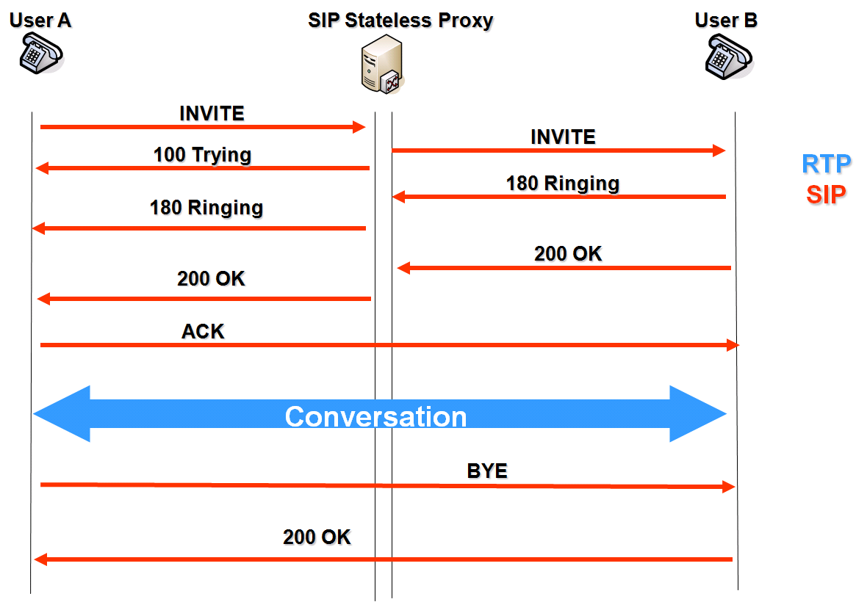

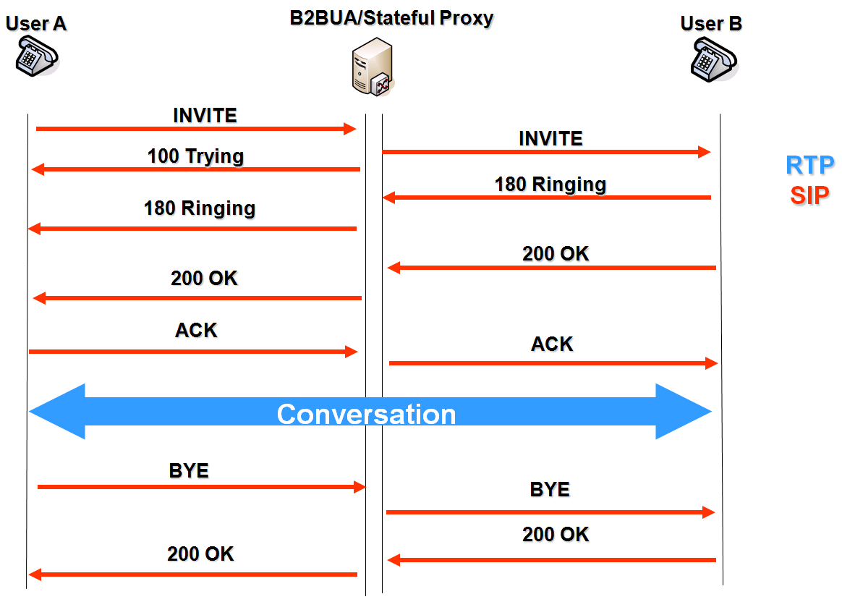

* **TLibrary (TLib)**

- SIP Server communicates with Genesys Suite using TLibrary protocol (TLib).

**B2BUA vs SIP Proxy**

* + B2BUAserver and Stateful SIP Proxy stay in the signaling path during the entire session. Stateless SIP Server doesn’t.
  + B2BUA mode provides 3PCC (third party call control)
  + B2BUAmode allows SIP clients to communicate with Media Servers
  + B2BUA mode allows SIP Server to work as an Application Server behind soft switches
  + B2BUAmode can handle SUBSCRIBE/NOTIFY and any future SIP extensions.

1PCC, First Party Call Control

All actions performed by the hold, initiate transfer, etc, are performed SIP endpoint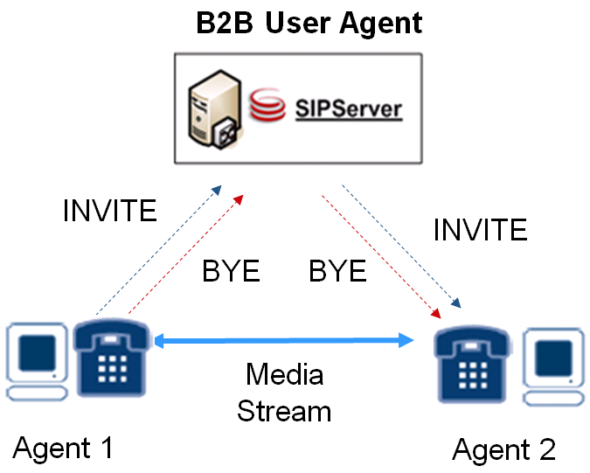

3PCC, Third Party Call Control

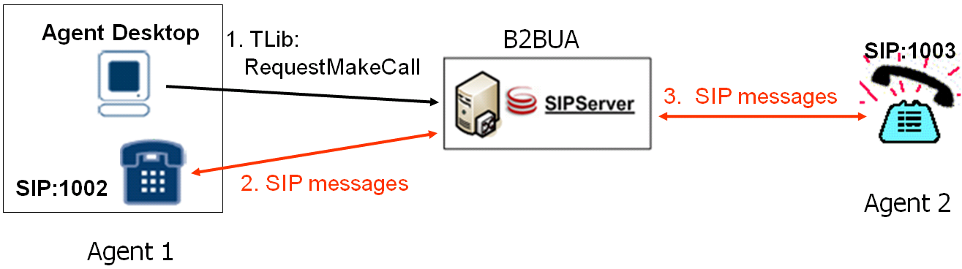

3PCC - ability of one entity (Agent Desktop) to create and control a call in which communication is actually between other parties (SIP phones)

# ROUTING

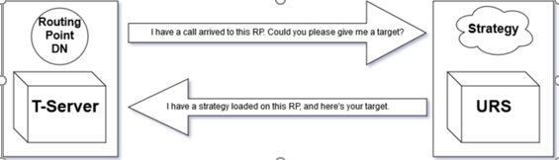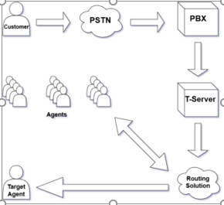

**routing strategy** is a set of decisions and instructions which tell URS how to handle and where to direct interactions under different circumstances. Think of a strategy as a structured set of choice-points, each of which analyzes some aspect of the current interaction.

**Strategies are saved in two components:**

* **Script object:**

- In Configuration Layer;

- Stores strategy details such as byte code and size;

* **.rbn file:**

- In file system or Configuration Database;

- Stores strategy graphics and object definitions.

**URS** stands for Universal Routing Server. This is a server that executes strategies which are loaded onto Routing Points. Responsible for founding a target agent for an interaction.

**Target** is the resource to which a strategy routes an interaction. Финальный этап стратегии

**Segmenting Interactions**

Routing strategies often begin with a Segmentation object that is used to separate incoming interactions and send them on different paths in the strategy.

**Possible voice routing targets include:**

• Agents

• Agent Groups

• Campaign Group

• Destination Label

• Places (desks)

• Place Groups

• ACD Queues

• Queue Groups

• Routing Points

• Skills (agents with certain skills or skill levels)

• Variables

• An object that is the result of applying a Routing Rule, which can allocate based on Load Balancing, Percentage, Service Level,

the value of a Statistic, or Workforce considerations.

**Possible multimedia routing targets include:**

• Queues

• Workbins (associated with an Agent, Place, or Place Group)

-//-//-

**ORS Orchestration Server, взаимодействие urs-ors -** Acts like URS(in pair), but runs its own strategies written in SCXML language; Designed to replace URS in the future; Allows to make much more flexible routing strategies compared to URS. Расширяет возможности genesis по маршрутизации. IRD use IRL. When the call arrives to RP, T-Server sends it to URS; URS, which is integrated with ORS, invokes it, and ORS runs its own strategy loaded on this RP; ORS returns the target to T-Server;

**IRD** – interaction router designer – средство позволяющее строить стратегии для urs, загружать их и мониторить.

**Objects in ird –** базовые строительные блоки стратегии. Red – error, timeout.

**Strategy Building Objects**

* **Treatments:** You can use the Treatment objects to apply a mandatory action to the call such as play a recorded announcement or collect data from the customer.
* **Database:** is the Database object used for searching the database for information such as a customer’s name or balance. Also represents Web Services.
* **Segmentation:** You can use the Segmentation objects to make decisions in the strategy such as is the customer’s preferred language Spanish or does the customer have a Platinum account status.
* **Routing:** You can use the Routing objects to select targets for the customer interaction such as an agent or a queue.
* **Miscellaneous:** You can use the Miscellaneous objects to help control the flow of the strategy such as marking the strategy’s beginning or ending.
* **Multimedia:** represents the multimedia (emails, chat) objects. You can use the Multimedia objects to help control how a multimedia interaction should be routed in the contact center.
* **Outbound:** objects related to Genesys Outbound Server. Not covered by this course.
* **SMS:** allows us to create and send SMS messages to the customer.
* **Workflow and Resource Management:** provides functionality to control agent’s state (ready/not ready), log him out or change the strategy state.

**Functions** can perform a task such as returning call information or attaching data; Function categories include:  
Call Info, Miscellaneous, Configuration Options, Reporting,  
Data Manipulation Statistical, Date/Time, String Manipulation, List Manipulation, Target Manipulation, Force

# INSTALL URS

1. Import application template;
2. Create application from template in Configuration Server database;
3. Create all needed connections between URS and other apps;(to urs: IRD, SIP, STAT, from urs: SIP, SCS, STAT, MS)
4. Configure URS application;
5. Install URS;
6. Create and load strategy;
7. Test it;

URS LOG: процессинг стратегий, апликейшн оперетионал.

## Options

**on_route_error**

Instructs URS which action to take if an external error, such as EventError from T-Server, occurs after URS issues an instruction for definitively routing the interaction as a result of a Routing object. This option only works for interactions routed to destinations specified in the Routing Selection object. The option does not work for interactions routed to destinations which use the SelectDN and RouteCall functions.

**• “Delete”** means that URS will delete the interaction and stop the strategy.URS will assume that the interaction was not routed successfully. At this point, nothing can be done to reroute the interaction.

**• “Ignore”** means that URS will disregard the error and continue waiting for the EventRouteUsed event that confirms successful routing.

**• “Default”** means that URS will attempt to send the interaction to a default destination.

**• “Reroute”** means that URS will try to route the interaction again on the basis of the same Routing object. URS assumes that the interaction is still at the routing point and will immediately reissue TRouteCall.

**• “try_other”** means that URS will resume waiting for a ready target and try to select another available target. Unlike the reroute value in which URS immediately attempts to reroute the call, for try_other URS waits for another target if none are available before routing the interaction.

**• “Strategy_ok”** means that URS will abort current waiting for a ready target and continue with the strategy. In this case, the error from T-Server will have the same effect as absence of a ready target—URS simply resumes the strategy to the error-handling object.

**• “Strategy_error”** means that URS will abort current waiting for a ready target and go to error handling in accordance with the Error object.

**verification_time**

A positive value is useful when it is possible for an agent to pass through ready state in a transition between ending a call and making himself unavailable by a manual command. This option specifies the time, in seconds, that must elapse after an agent ends a call before the agent is reported as ready to receive calls again. **( Этот параметр определяет время в секундах, которое должно пройти после того, как агент завершает вызов до того, как агент сообщается как готов к приему вызовов снова.)**

This option is applied every time an agent becomes ready, not just after ending a call. It is not related to any previous interaction and it is not necessary to have finished a previous interaction.

When CheckAgentState is set to false or function UseAgentState is used, URS does not apply the verification_time option to agents, but still applies it to agent DNs.

**transition_time**

Specifies the minimal time, in seconds, for which URS will wait between the moment an interaction is routed to an agent, a place, or a DN, and any subsequent check for routing to the same agent, place, or DN. A nonzero (3 or higher) value is needed to avoid repeated routing to the same agent or place before Stat Server has reported the agent or place as busy. The value of this option should be increased when interaction traffic and network traffic intensify. The default value of 15 should ensure enough time for Stat Server to report an agent’s change of status. (время, которое urs будет ждать после того как звонок направлен на плэйс, агента или дн. В это время на эти таргеты ничего не отроутится)

**agent_reservation**

This option enables two or more Universal Routing Servers to work cooperatively and prevents them from trying to route to the same target. To turn agent reservation on, this option must be true for URS.

**Note:** If you have URSs routing to the same set of agents, agent reservation is mandatory.URS sends a reserve request to the T-Server and sends the interaction only when the request is confirmed. When a T-Server reserves an agent, place, or DN, it prevents any other URS from sending an interaction. The target is reserved for a duration equal to the value of **transition_time**.

**Note:** If **reservation_pulling_time** is set to 0 (default) URS will not wait for a reservation response in any target Selection object with a wait time set to 0. As a result, the target Selection object will timeout even if atarget was found.

URS sends a reserve request to the T-Server and sends the interaction only when the request is confirmed. When a T-Server reserves an agent, place, or DN, it prevents any other URS from sending an interaction. The target is reserved for a duration equal to the value of **transition_time**.

**Important Universal Routing functionality includes:**

• Database-driven routing.

• Agent-level routing, including workforce routing.

• Skills-based routing.

• Virtual agent groups with priority routing across virtual queues.

• Service-level routing.

• Multi-site routing.

• Statistical routing.

• Routing voice interactions across tenants.

• Business Attribute assignment.

• Priority tuning for voice interactions.

• Strategy debugging.

• Sharing strategies between environments.

• High availability of Enterprise Routing and Network Routing.

• Support for business processes.

• Specialized interaction processing objects.

• Open media support.

• Routing to and setting thresholds for non-configured DNs.

• Routing using agent capacity information.

• Strategy support for ring-no-answer situations.

• Service level agreement routing.

• Cost-based routing.

• Support for proactive routing.

• Support for agents participating in multiple outbound campaigns

• Support for load balancing.

• Session Initiation Protocol (SIP) support.

• SCXML-based routing strategy support.

• URS Web Interface.

• Overloading Control Features.

Each function is briefly discussed in the following sections.

Database-Driven Routing

## Types of routing

**Database-driven routing**

means that an interaction is routed based on database information. You can build a strategy that instructs URS to:

1. Query a database for any available information, including customer name and language, but also for account level, ID of thelast agent who handled the customer, and so on.

2. Attach this information to the interaction.

3. Route the interaction to the appropriately skilled agent.

4. Request services from Web-based applications.

**Agent-Level Routing**

Agent-level routing enables interactions to be routed to a specific agent, for example, if you try to route a call to the last called agent. You can design a strategy that stores the agent ID with the customer information in a database or attaches it to the

interaction. Another type of agent-level routing**, workforce** routing, routes interactions according to agents’ scheduled activities.

**Service-Level Routing**

Service-level routing enables interactions to be routed according to specified service-level requirements for service types and customer segmentation. For example, a business might have two service-level requirements:

• Ninety percent of interactions received from premier customers must be answered in 10 seconds.

• Eighty percent of all interactions must be answered in 20 seconds.

**Multimedia Routing**

enables the blended contact center. Routing strategies can control automatic email receipts and email replies according to content analysis rules, which are trained to respond specifically to your customer base.

**Skills-Based Routing**

You can also develop skills-based routing (also called agent-based routing) strategies, so that interactions are routed to the most appropriately skilled agent based on the needs of the customer.

**//////////////////////////////////////////////////////////////////////////////////////////////////////////////////////////////////////////////////////**

**//////////////////////////////////////////////////////////////////////////////////////////////////////////////////////////////////////////////////////**

**//////////////////////////////////////////////////////////////////////////////////////////////////////////////////////////////////////////////////////**

***Virtual Agent Groups***

*Virtual agent groups group together agents with similar skills or responsibilities regardless of their work location. Stated another way, a group of agents is considered to be virtual if agents do not permanently belong to the group. Instead, Stat Server assigns an agent to the group when an agent meets the criteria specified by the virtual group’s definition. Stat Server adds agents to, or removes them from, the group if agent parameters that affect eligibility change or if the specified criteria are modified.*

***Multi-Site Routing***

*Genesys supports routing across the contact center. Multiple sites—and all available agent resources—serve as one virtual contact center. Interactions are routed according to business criteria and best available agent, regardless of location. Genesys TServers support switches that transfer interactions between sites, so you can route interactions to contact centers at different sites and between different departments at different sites. This results in reduced administrative expense and increased workforce flexibility.*

***Statistical Routing***

*You can route interactions based on the value of a statistic.*

***Routing Interactions Across Tenants***

*The Switch-to-Strategy object uses a routing rule to tell URS to route the interaction to the starting point of another strategy. When using this object, you can select the Tenant name associated with the switched-to strategy.*

***Support for Business Attributes***

*Business attributes are interaction attributes that are used in different ways by various Genesys applications.*

*The origin of Business Attributes varies:*

*• Some Business Attributes are predefined by Genesys and can be expanded.*

*• Other Business Attributes are customer-defined in Configuration Manager.*

*• Other Business Attributes are initially defined in Knowledge Manager and then carry over to Configuration* ***Priority Tuning (Voice Interactions)***

*Manager.*

*In an interaction-surplus scenario, URS selects the most appropriate interaction across virtual queues when a skilled agent target becomes available. An interaction-surplus scenario happens when a skilled agent handles interactions from multiple virtual queues because of membership in multiple agent groups or in a group based on a skill expression. In an interaction-surplus scenario when routing voice interactions, URS can select the most appropriate interaction according to the following priority tuning factors:*

*• Highest assigned priority number*

*• Longest relative wait time such as wait time in queue, age of interaction, or what-if wait time*

*• Greatest service objective risk factor (a weighted value of relative wait time to service objective of the interaction)*

***Strategy Debugging***

*The strategy debugging tool makes it easy to locate and resolve syntax errors and logic problems in your strategies. The*

*debugger verifies the syntax of each strategy statement, tests it on a fictitious interaction, and evaluates every function used. You can*

*also view and edit the value of variables.*

*The debugger’s gives you the advantage of being able to test a strategy without connecting to outside applications. The*

*debugger simulates data and statistics that it would get from Stat Server in a real environment.*

***Sharing Strategies Between Environments***

*With IRD, you can share strategies between configuration environments. To do that successfully, you must provide the*

*destination environment with all of the strategy-related objects used in the source strategy.*

*IRD provides an automated process to package all strategy-related objects that IRD created in the source environment and to*

*extract the same objects in the destination environment. To do this, IRD creates a strategy-moving file to move objects from a*

*source environment to a destination environment.*

*However, you must use Configuration Manager to manually create objects such as fields, formats, and tables that IRD is not*

*responsible for creating.*

*After exporting and importing, IRD generates export and import log files that contain detailed information about the objects that*

*were or were not successfully packaged and extracted between configuration environments.*

***High Availability***

*High availability refers to the percentage of time that a routing solution is available to process routing interaction services*

*according to a specified performance criteria above a given performance threshold which depends on system architecture.*

***Business Process Support***

*If you are using Genesys eServices (formerly Multimedia), IRD provides an Interaction Design window for creating business*

*processes. A business process directs incoming interactions through various processing objects with the goal of delivering an*

*appropriate response to the customer.*

*• In the case of an e-mail interaction, an appropriate response might be an e-mail message that answers the customer’s questions.*

*• In the case of a chat interaction, an appropriate response might be mailing product brochures to the customer.*

*• In the case of a fax interaction, an appropriate response might be an e-mail message that states the requested materials had*

*been received.*

***Specialized Interaction Processing Objects***

*Interaction Routing Designer (IRD) contains specialized objects that enable strategy designers to create non-voice routing*

*strategies that are called by eServices business processes. These objects can:*

*• Generate an acknowledgement e-mail message.*

*• Generate an autoresponse e-mail message.*

*• Request Classification Server to classify interactions for relevance to site-defined categories and return classification codes that*

*can be used for routing.*

*• Manually assign classification categories.*

*• Segment incoming interactions on classification codes.*

*• Screen interactions for certain words or word patterns.*

*• Request E-mail Server to attach a chat transcript to an e-mail message.*

*• Request E-mail Server to forward (with the expectation of getting a response back) e-mail to other agents or experts.*

*• When an external resource reply comes back as a result of a forwarded e-mail message, take the reply e-mail message as input,*

*extract the reply text from it, and create a customer reply outbound e-mail message.*

*• Enable you to interact with Web-based applications (Web Services) outside of Genesys applications. You specify request*

*parameters, what type of data you expect to be returned, and what to do with the returned data.*

*• Request E-mail Server to redirect (no expectation of a response back) interactions to other agents or experts.*

*• Place an interaction in an internal queue.*

*• Route an interaction to a specified target type (Agent, Agent Group, Campaign group, Place, Place Group, Variable, or Skill).*

*• Route an interaction to a workbin, a temporary storage area associated with an Agent, Agent Group, Place, or Place Group.*

*• Send an interaction waiting in a queue to a customer or another agent.*

*• Stop interaction processing and (optionally) notify Universal Contact Server or a third-party server (through Interaction*

*Server) that interaction processing has stopped for a specified reason.*

*• Create a new outbound e-mail message, a notification message, or an e-mail message that can be translated into Short Message*

*Service (SMS) format.*

*• Identify one or more contacts in the UCS database that match data attached to an interaction or, if no such contact exists,*

*create a new contact using the attached data.*

*• Update contact information by overwriting data in the UCS database with that attached to an interaction. You can also use*

*the Update Contact object to add more data fields to an existing contact.*

***Open Media Support***

*To support Open Media, IRD supplies general-purpose objects for use in routing strategies that are applicable to all media*

*types. These include objects for sending interactions to queues, attaching classification categories, and stopping interaction processing.*

*There is also an External Service object that can be used for all media types that you can use to route strategies called by*

*business processes. This object can be used to exchange data with third-party (non-Genesys) servers that use the Genesys*

*Interaction SDK or any other server/application that complies with Genesys Interaction Server communication protocol.*

*Routing To and Setting Thresholds for Non-Configured DNs*

*You can count the number of calls at DNs that are not configured in the Configuration Database and use this count for*

*routing decisions (RStatCallsInQueue statistic).*

***Routing Based on Agent Capacity***

*Capacity rules assigned to agents (Person objects) define a resource’s ability to handle multiple interactions. An agent-capacity*

*rule is a set of logical expressions that specify the boundaries of a resource’s ability to handle one interaction or more than one*

*simultaneous interaction of differing media types.*

*By default, URS is required to use agent-capacity information supplied by Stat Server when routing non-voice interactions. For*

*example, URS must use agent-capacity information in a blended environment (such as when routing e-mail plus voice or e-mail plus*

*chat) or when or routing other media types (such as when routing only e-mail or only chat).*

***Strategy Support for Ring-No-Answer***

*A ring-no-answer scenario occurs when URS sends an interaction to an agent because the agent has indicated that he or she is*

*in a Ready state. However, in reality, the agent has stepped out without changing his or her status into Not Ready. In this case, a*

*ring-no-answer scenario occurs. Some PBXs can detect this scenario and re-route the call.*

***Service Level Agreement Routing***

*Share Agents by Service Level Agreement (SLA) routing uses cross-trained agents. It enables a business user that manages*

*multiple business lines to define the triggering conditions and constraints that allow agents to be shared among business lines. With*

*Genesys share agents by SLA routing:*

*• You can define a specific set of activation conditions for the main business line to invoke shared agents (that is, to borrow*

*agents).*

*• You can also define the “Guarding” conditions so that the shared agents who are eligible to receive calls/interactions from*

*non-primary business lines do not affect their own business goals negatively.*

***Cost-Based Routing***

*Cost-based routing (CBR) enables Universal Routing Server to:*

*• Calculate the cost of routing to any target based on configuration information, statistical values, and its own data.*

*• Use the cost of routing to target as additional target selection criteria.*

*• Use information contained in strategies to activate/de-active cost-based routing during target selection.*

*• Automatically attach to interactions information required for cost-based routing reporting.*

***Proactive Routing***

*The IRD Routing Design window provides strategy-building objects that support Genesys Outbound Contact, a product for*

*creating, modifying, running, and reporting on outbound campaigns for proactive customer contact.*

*You can use the Outbound strategy-building objects to automate the building of customer Calling Lists, finish processing a*

*Calling List record, reschedule a customer call, and update a Calling List record. You can also add customer records to Do Not Call*

*lists from within a strategy. The generic External Server IRD object can be used to process other requests for Outbound proactive*

*customer contact, such as Record Cancel and Record Reject.*

***Multi-Campaign Agents***

*To support Genesys Outbound Contact and agents participating in multiple Outbound Campaigns, Campaign Group is a target*

*type in the Routing Selection and Route Interaction strategy-building objects. Functions SelectDN and SData add Campaign*

*Group target as a parameter.*

***Load Balancing***

*URS supports load balancing for both Enterprise Routing and Network Routing with or without Load Distribution Server, as*

*well as IVR Server load balancing. You can load balance among multiple URSs or load balance between routing targets using statistics.*

***Session Initiation Protocol Support***

*Genesys SIP Server is a combined T-Server and a call-switching component, in which the call-switching element functions as a*

*Session Initiation Protocol (SIP) Back-to-Back User Agent. In concrete terms, this means that call switching and control is*

*performed by Genesys—no third-party PBX or ACD system is required.*

*Universal Routing Server can work with SIP Server to support both chat and instant messaging (IM) sessions between agents*

*and customers.*

***SCXML-Based Strategy Support***

**

***Overloading Control Features***

*Beginning with Universal Routing Server 8.1.4, URS includes overloading control features.*

*Part of system availability is addressing those cases in which URS, while still running, experiences conditions which prevent it*

*from providing the expected level of service.*

*Two main types of cases are:*

*• Stat Server is overloaded to the extent that it cannot provide statistic information to its client. Both Primary and Backup Stat*

*Server, dedicated for processing of multimedia and voice interactions, can temporarily switch to CPU saving mode with disconnection*

*of all clients, including URS.*

*• URS itself is overloaded due to abnormally high rates of incoming calls or some configuration changes which require URS to*

*rebuild/recheck all its queues.*

**//////////////////////////////////////////////////////////////////////////////////////////////////////////////////////////////////////////////////////**

## Sample Interaction Flow, Enterprise Routing



Customer Contact

1. A customer contacts a business and the interaction enters the premise PBX switch system.

2. The PBX switch requests routing instructions from the T-Server, which creates a unique identifier for the interaction.

3. T-Server converts the request to a TCP/IP message (the language understood by Genesys applications) and passes the request to Universal Routing Server (URS). URS Execution

4. URS executes the routing strategy designed in Interaction Routing Designer. The strategy includes instructions to collect customer-entered information. According to the sample flow, URS first sends the interaction to an IVR to prompt the customer to enter an account number and language preference.

5. Customer enters the account number and a French language preference and the IVR attaches this data to the interaction.

IVR routes the interaction back to URS.

6. URS queries the customer database through the DB Server to determine the identity of the customer.

7. The strategy attaches the database information about the customer to the interaction.

8. URS queries Stat Server to determine which French-speaking agent is available.

9. URS learns from Stat Server that one or more agents are available and determines the agent to whom the interaction should be routed.

10. URS sends a RequestRouteCall message to the T-Server. The message contains the agent information (DN, Connection ID) and the collected customer information.

11. T-Server tells the switch to route the interaction to the Agent DN.

12. The PBX routes the interaction to the agent while T-Server

provides the attached customer information to the agent's desktop application.

**Sample Interaction Flow, Network Routing**



Customer Contact

1. A customer contacts a business through a Network Switch.

2. An interaction notification enters the Service Control Point (SCP) from a Network Switch.

3. Based on the Service Number dialed, the SCP determines where to trigger a routing request. The SCP generates a routing

request to Network T-Server. The ANI, CED (caller-entered-digits), and DNIS are passed to the T-Server in the request along

with other attached interaction data.

4. Network T-Server sends an EventRouteRequest message to Universal Routing Server (URS).

URS executes the strategy. The ANI, CED, DNIS, and other attached data are passed in the request.

URS and Target-Selection Analysis

5. URS consults Stat Server to determine the availability of the targets based on the skill and proficiency level requirements of

the routing strategy.

6. URS learns from Stat Server that one or more of the targets are available, for example, an agent with DN 4444 on premise

switch 2.

7. URS selects a target and from the data returned by Stat Server determines which premise T-Server will need to be

consulted for an external routing point.

URS passes interaction information (Agent DN, Connection ID, User Data) directly to the Network T-Server.

8. The Network T-Server communicates with the premise T-Server to determine which external routing point, for example, 9999,

should be reserved to receive the interaction and returns that DN to the Universal Routing Server.

9. URS then consults the Switch Access Code tables from the network switch to premise switch 2 for target type Target

Agent. The table has a value of [DN.DL] in the Destination Source field. URS consults the DN group associated with the

external routing point supplied by the premise T-Server in Step 7 (DN 9999). The DN group contains a single Network

Destination type DN defined for the network switch. This completes the network number translation process.

Interaction Routing

10. URS sends a RequestRouteCall message to the Network T-Server for the derived destination. The RequestRouteCall

message contains the DL produced by URS in Step 9.

11. The Network T-Server tells the Service Control Point to send the interaction to the derived destination for the target by

the trunk that the Network Destination points to.

12. The Service Control Point instructs the Network Switch to route the interaction using the given Network Destination.

13. The interaction arrives at External Routing Point 9999 on the destination premise switch.

14. The premise switch sends the interaction arrival message to the premise T-Server. The rest of the interaction flow is now

entirely controlled by the premise T-Server.

15. Since the premise T-Server knows the target agent DN, the premise T-Server instructs the switch to route the interaction to

agent DN 4444.

16. The interaction is routed to the agent DN.



## Inbound Voice Routing Architecture with IRD:

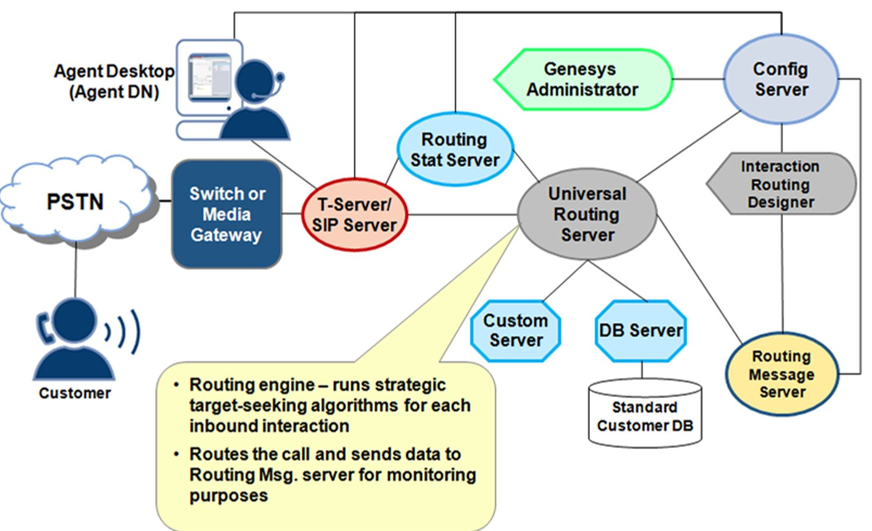

## There are two ways how URS can connect to a database when using Interaction Routing Designer:

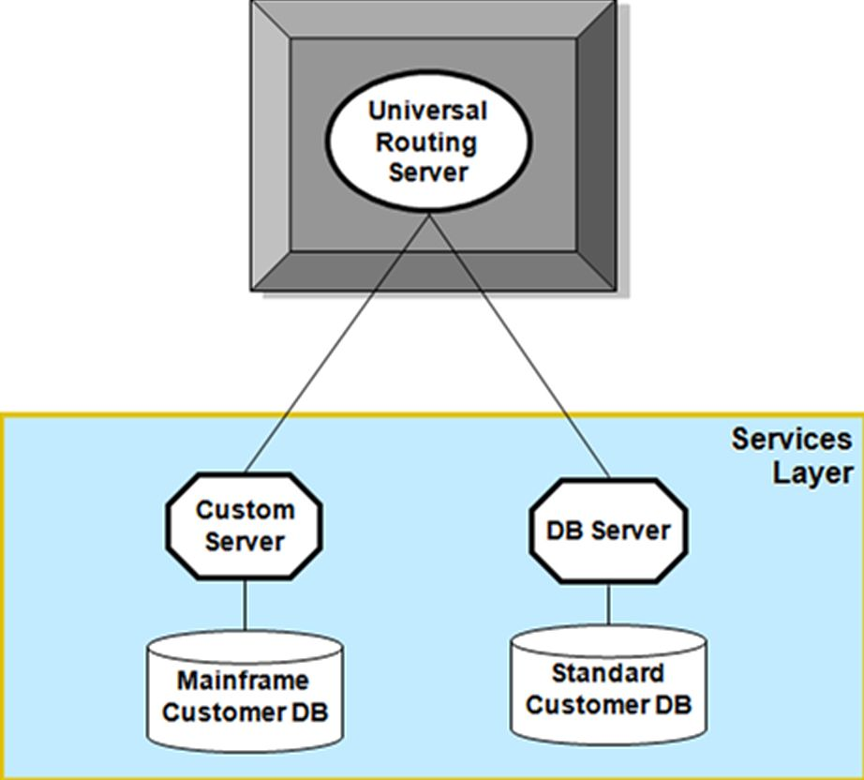

**DB Server: For relational database management systems (Oracle, Microsoft SQL Server, Sybase, Informix, DB2)** The DB Server's role in the routing solution is to provide the routing engine with access to enterprise customer data

**Custom Server: For mainframe or non relational databases Translator between URS and the Router Custom Procedure (RCP) library which can be programmed as needed**

Custom Server allows URS to retrieve and send data from non-compliant databases (legacy database systems) using a custom procedure. The IRD interface for defining a custom procedure is identical to the interface used for a SQL stored procedure. Also, Custom Server can serve as an interface to third party applications.

**Place of URS and IRD**

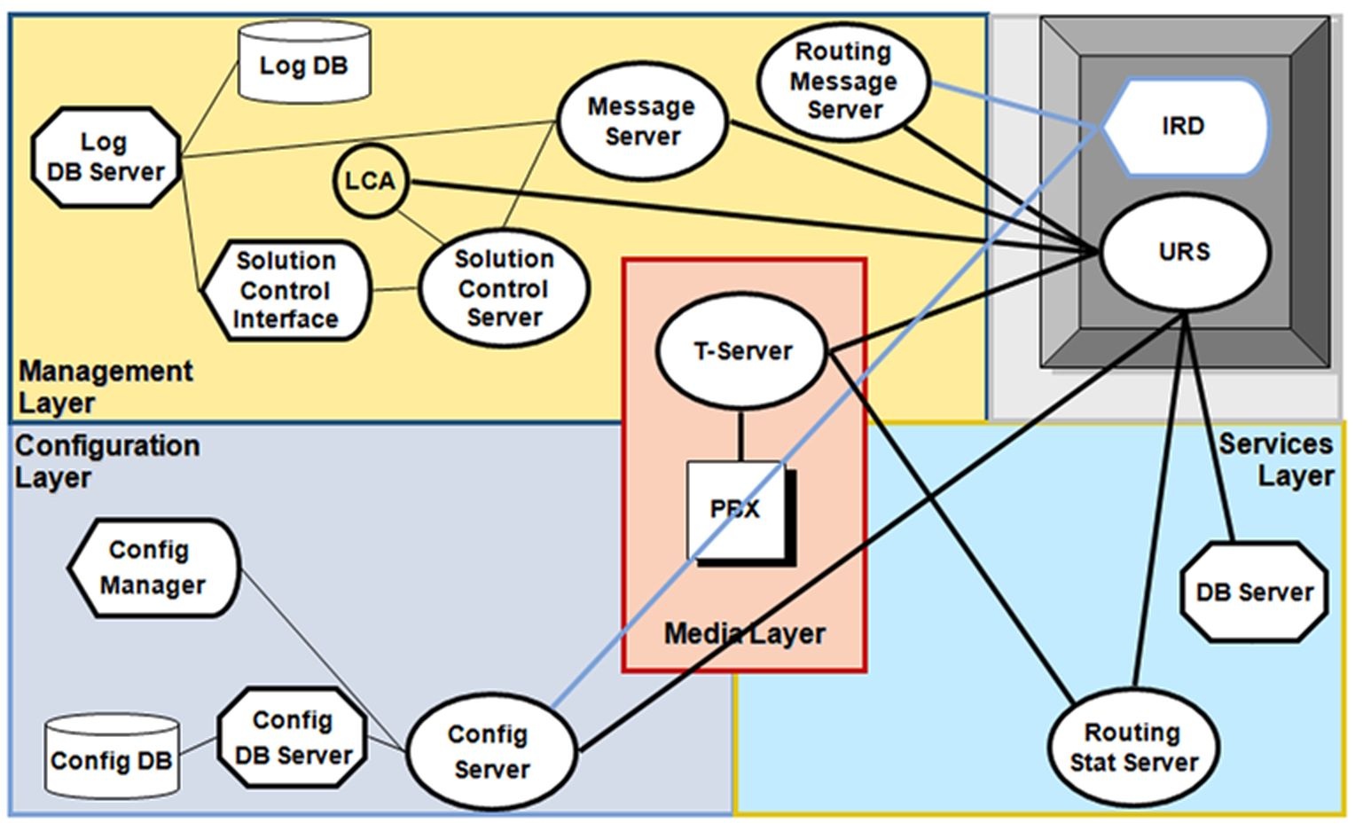

## Load Distribution Server

**LDS is designed to increase system performance in contact center environments with high call volumes. LDS enables load sharing in situations where the total traffic of a large installation exceeds the capacity of individual Receivers. Using LDS with multiple Receivers also increases redundancy in a configuration.**

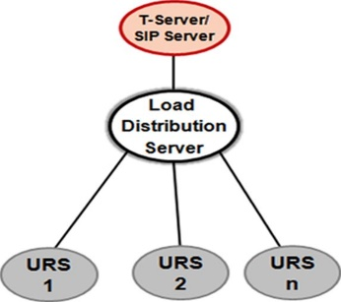

# *Interaction Flow: Simple Routing*

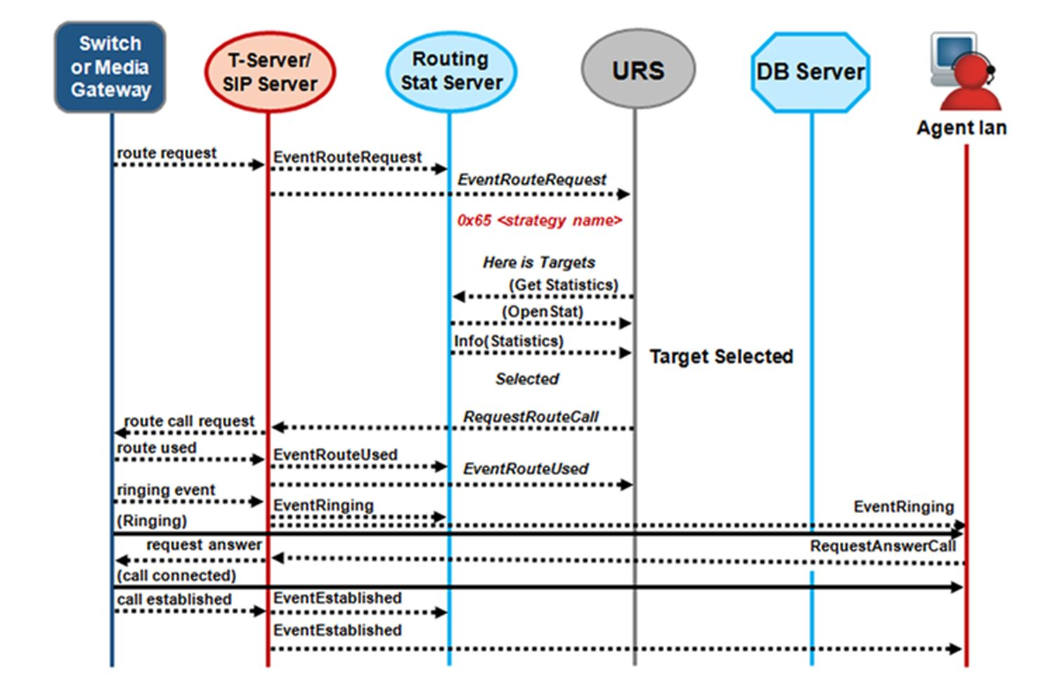

## Events

By the first, we’re receiving **EventQueued** from SIP Server, which means that the new call landed on its Routing Point

Next, we’re receiving **EventRouteRequest** from SIP Server, which means that T-Server wants URS to find appropriate target for this call.

As we received **EventRouteRequest**, URS checks which strategy is loaded onto this RP and attaches it to the call.

DN in ready state

Looks like a good target. Let’s send our call to this agent.

To do this, URS sends **RequestRouteCall** to T-Server containing all required target information (target DN).

On his turn, T-Server replies with **EventRouteUsed** which means that he sent call to the selected target

**EventRouteUsed**

The EventRouteUsed message is a report to URS about successful processing or a command to cancel strategy execution for this interaction. EventRouteUsed message does not mean that the call was successfully delivered, rather that the call left the route point and is used by Stat Server for statistical purposes.

**Call Deleting**

The call deleting truly message means that the strategy is now over. The end of the strategy results in the stop interpretator message, followed by call deleting truly (removed from URS memory).

**Multi-Site Routing**

Genesys supports routing across the contact center, this includes multiple sites - and all available agent resources - serve as one virtual contact center

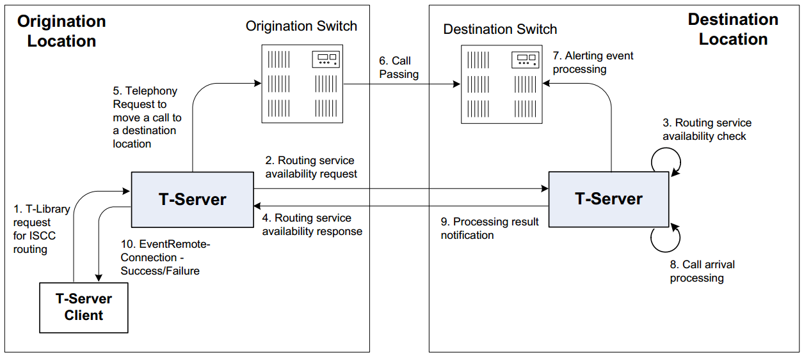

## Inter-Server Call Control (ISCC)

ISCC is an internal T-Server component responsible for T-Server's multi-site operations such as multi- site call transfer, inter-site call linkage, call overflow, and other, possibly non-call-related multi-site operations.

* **Component of T-Server that supports multi-site operations**
* **Coordinates critical information about a call travelling from one switch to another**
* **Call Matching**
* **Call Data SynchronizationConfiguring (ISCC)?**
* **Maintains connections to other T-Servers**
* **Registers for all DNs of type External Route Point**
* **External Routing Points are exclusively used by ISCC**
* **URS does not register them, just ISCC**

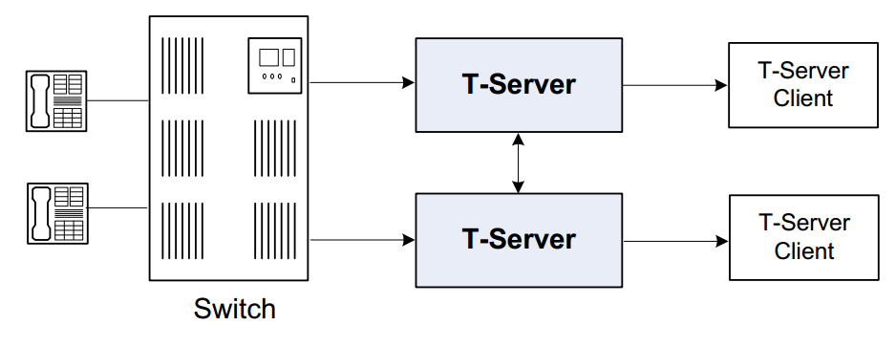

## Multi-Site Routing: Messaging

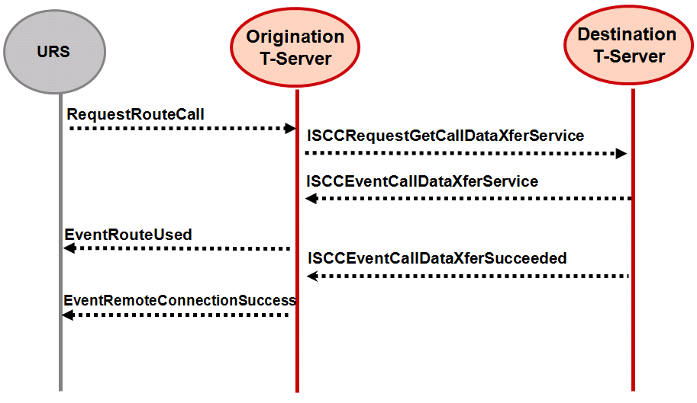

**1. ISCC is invoked with a RequestRouteCall from URS that includes AttributeLocation specifying a remote switch.**

**2. ISCC issues ISCCRequestGetCallDataXferService to the T-Server corresponding to the remote switch to request access resources. This message includes the ConnID, UserData and Call History for the call from the origination T-Server.**

**3. Once an Access Resource is available, the destination T-Server responds with ISCCEventCallDataXferService providing the access number to reach the destination.**

**4. ISCC sends RequestRouteCall to the local T-Server instructing it to route the call to the access number provided by the Destination T-Server.**

**5. If the Switch succeeds in sending the call. T-Server responds to ISCC with EventRouteUsed.**

**6. ISCC then sends URS an EventRouteUsed as the response to the initial RequestRouteCall.**

**7. The call was successfully matched (and routed from any External Routing Point), the destination T-Serv er notifies the origination T-Serv er that the routing service was successful and deletes all information about the request. - ISCCEventCallDataXferSucceeded.**

**8.T-Server notifies URS with EventRemoteConnectionSuccess.**

## Configuring (ISCC)

1. **Create connections between T-Servers:**

**On both sites T-Server/SIP Server applications must have a connection to each other**

**Configure ADDP to make those connections more reliable.**

1. **Check extrouter section in T-Servers option. Confirm option, cast-type = route.**
2. **Assign Switch Access codes for each site if necessary.**
3. **Create ERP DNs.**
4. **Create Trunk DNs (SIP Server only)**
5. **Develop routing strategy**
6. **Validate.**

**Open Standards-Session Based Platform**

ORS offers an open standards-session based platform with a State Chart Extensible Markup Language (SCXML) engine, which enables intelligent distribution of interactions throughout the enterprise. In conjunction with Universal Routing Server (URS), ORS can direct interactions from a wide variety of platforms, such as toll-free carrier switches, premise PBXs or CDs, IVRs, IP PBXs, email

servers, web servers, and workflow servers. ORS can handle pure-voice, non-voice, and multimedia environments, enabling routing of each media type based on appropriate

criteria. Routing strategies and business processes automate interaction routing to the most appropriate agent/resource based on factors such as the type of inquiry, the business value of the customer interaction, context and customer profile, and the media channel. ORS and CIM Platform ORS and URS are a part of the **Genesys Customer Interaction Management (CIM) Platform**, which provides the core interaction management functionality. The Platform is the collection of core servers that enable the rest of your

Genesys environment to process the thousands of interactions that represent the needs of your customers. The CIM Platform

consists of:

• Management Layer

• Configuration Layer

• Reporting

• Supervisor Desktop

• Universal Routing Server

• Orchestration Server

• Genesys Administrator

• Composer

**ORS and Multimedia**

Orchestration Server in conjunction with URS provides a platform for different Genesys solutions to work together managing interactions regardless of media type. By adding ORS to URS, you now have the possibility to coordinate processing of multiple interactions of different media types that are involved in a single service. As shown below, this multimedia capability includes some parts of the CIM Platform plus media channels that run on top of the Platform as follows:

• From the CIM Platform, ORS provides centralized handling of

interactions regardless of media type.

• From the eServices media channels, at least one of the following:

◦ Genesys Email

◦ Genesys Chat

Genesys Open Media-The ability to add customized support ◦

for other media (fax, for example)

Optionally, Web Collaboration - The ability for agents and ◦

customers to co-browse (simultaneously navigate) shared web

pages. This is an option that you can add to either Genesys Chat

or Inbound Voice.

An Orchestration solution can consist of many interactive



The Orchestration Platform consists of ORS and Universal RoutingServer (URS). The platform works with T-Servers, SIP Server, orInteraction Server quite similarly to the way URS previously worked with these components. In this architecture, requests from these services go to ORS and utilize URS services for routing. A high level architectural diagram is shown below.

**Composer**

Within the Orchestration Platform, Composer serves as the IntegratedDevelopment Environment to create and test SCXML-based routing applications executed by ORS. An application server is utilized to

provision SCXML routing applications to ORS. See Composer infigure above.

**Cassandra**

The Orchestration Platform provides persistence of customer sessions by utilizing Cassandra NoSQL DB, which is packaged and built-in with ORS (see Cassandra in figure above). A session refers to a period of time during which ORS executes an SCXMLbaseddocument, such as one that defines a routing strategy created in Composer. Cassandra stores information regarding active

sessions, as well as scheduled activities.

**Voice Interaction Flow**

The figure below shows a sample voice interaction flow that is based on the above architecture diagram.

The following explanation describes the sample voice interaction flow.

1. A new interaction arrives for T-Server (EventRouteRequest). TServer notifies URS and ORS.

2. The configuration is enabled to use an ORS application, so ORS asks the Application Server for an SCXML application session.

3. The Application Server provides an SCXML application to ORS. ORS starts execution of the SCXML application (HTTPOK).

4. At times during the SCXML application execution, ORS asks URS for assistance with tasks, such as routing.

5. It invokes Functional Modules via SCXML action events, shown here as RUN.

6. URS performs the required action(s), shown here as RUN, and reports the results to ORS.

7. If needed, URS sends a request to T-Server. In this example, URS sends a request to T-Server that corresponds with the routing

request that ORS sent to URS in Item 7 (queue.submit).

8. URS performs the required action(s), shown here as RUN, and reports the results to ORS.

9. If needed, URS sends a request to T-Server (RequestRouteCall).

10. Then EventRouteUsed occurs.



**Multimedia Interaction Routing**

The following sequence diagram illustrates a scenario for basic multimedia (eServices) interaction routing.

The numbered steps in the preceding figure are identified asfollows:

1. ORS pulls the next multimedia interaction from a queue.

2. When the interaction is successfully pulled: Application Server receives a strategy request; URS is notified aboutthe new interaction (and prepares to begin processing).

3. A new session starts, and an interaction.present event is fired into the session, which allows the interaction to be processed.

4. The SCXML application submits a request to Interaction Server to auto respond to the interaction.

5. After this, a queue:submit action is invoked which locates the appropriate resource to process the interaction.

6. When an available resource is found, the interaction is delivered to this resource.

7. When the interaction is redirected to the resource: interaction.notcontrolled is fired into the session; URS also is notified that the interaction is not controlled.



**Deployment Models**





**//////////////////////////////////////////////////////////////////////////////////////////////////////////////////////////////////////////////////////**

**//////////////////////////////////////////////////////////////////////////////////////////////////////////////////////////////////////////////////////**

**//////////////////////////////////////////////////////////////////////////////////////////////////////////////////////////////////////////////////////**

# E- Services

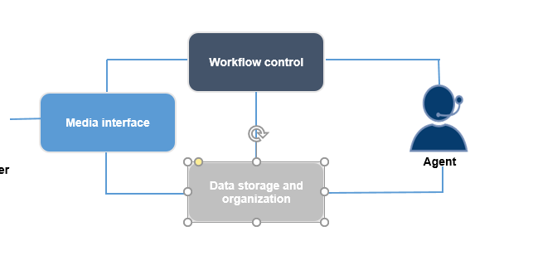

* The media interface, which brings interactions into the system. It may interface with e-mail, chat, or other media.

The “standard” media interfaces available with eServices 8.5 are E-mail Server, Chat Server, Social Messaging Server, and SMS Server.

* Data storage, which stores the history of the interaction and associates it with related interactions to form a thread.

It also stores contact information and other types of data used at different points in the processing of interactions.

- Workflow control, which determines where the interaction goes and what happens to it.

**Media Server**

Source/receiver of outbound/inbound operations. Out of box in genesys :

Email server, chat, social media, sms , web api server. Can be created using genesys sdk.

**Agent Desktop**

* Receives interactions, iWS: Can handle all standard media types

**Business Process -** directs customer interactions that arrive at the contact center through various processing objects. It defines what happens to customeri nteractions from the point of arrival to the point of completion. **Stored in the form of script objects in Configuration Server**

**Итнеракция -**  сушьность, которую используют дженесис сервера, чтобы обеспечить взаимодействие агента и клиента.

**Interaction workflow -** An interaction workflow implements the procedures used by agents,

supervisors, quality assurance, and other personnel in your company to accomplish business objectives related to incoming interactions. This workflow can be broken down into various segments. IRD enables you to represent such segments as individual business processes. A business process is a logically-organized series of steps that, working together, handle a task or some aspect of a task and that therefore contributes to your overall workflow processing. Think of business processes as containers for performing general tasks, such as moving interactions in and out of queues

**Interaction queue** - represents a logical parking place (persistent queue) (**inside the Interaction Server database**) for an interaction during its lifetime at the contact center. Interactions leave an Interaction Queue for further processing based on default or user-defined conditions. **May be connected to 0 – N strategie**.

A synthetic queue is a queue that is composed of multiple interaction queues.

**Business Process Queue**—represents interactions located in any queue that belongs to the same Business Process as the Business Process queue. A Business Process Queue can be used to define

processing for all interactions of a given Business Process

◆ **Synthetic Queue**—represents interactions located in any queue that is listed in the Synthetic Queue configuration. A Synthetic Queue can be used to define processing for all interactions in a specific group of Interaction Queues.

◆ **Tenant Queue**—represents interactions located in any queue that belongs to the same tenant as the Tenant Queue. A Tenant Queue can be used to define processing for all interactions that belong to a tenant

**Condition Tab(queue) -** This section describes the tab on which you specify the condition for extracting interactions from queues.

**Order -** Here you have the option of defining the order for pulling interactions from the queue when using this view.

**Scheduling Tab**

This section describes how to schedule submitting interactions to a routing strategy.

**Segmentation Tab**

Use the Segmentation tab on the View Properties dialog box to submit an equal number of interactions of different segments and to limit the total number of interactions that can be submitted to a strategy.

*Submitter object*. It represents interactions being pulled from the queue and pushed (submitted) to a routing strategy.

**Workbin** -Like a queue, a workbin holds (parks) interactions. However, a workbin is associated with a particular agent/place group and its major function is to hold interactions for that agent/place/group to process. In IWS, agents can use workbins to store interactions that they have started working on and wish to continue working on at a later time. Interactions can be distributed to workbins by Universal Routing Server when executing a strategy that uses the Workbin object. Agents can view the entire content of a workbinand pull interactions from it in any order.

An endpoint can be used to connect a media serve with a queue in a business process.

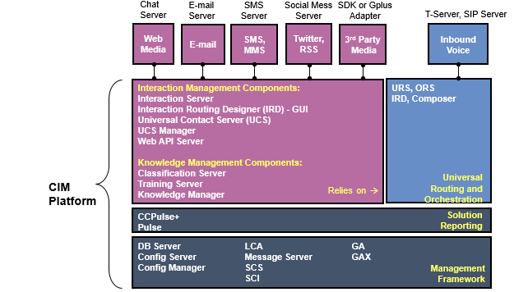

**Interaction Server vs. Routing Engine**

* **Interaction Server**
  + **Accepts new interactions and saves them in an Interaction Queue**
  + **Manages communication with URS**
  + **Submits interactions to strategies and processes responses**
  + **Delivers interactions to the agent and provides inter-agent operations**
  + **Stops interactions upon request**
  + **Supports communication between URS and media interfaces**
  + **Provides reporting information to reporting clients like Stat Server**
* **URS**
  + **Executes strategies for interactions submitted by Interaction Server**
  + **Communicates with media interfaces *through* Interaction Server**
  + **Invokes methods in external services via External Services Protocol (ESP) to retrieve user data and/or routing data from 3rd party servers**

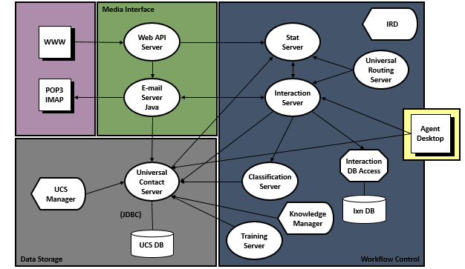

## Servers

**Custom Media Interface**

**Interfaces with 3rd Party device, Interaction Server, and UCS to support 3rd Party interactions**

**Transmits operational data to Interaction Server**

**Web API Server**

**Collection of servlets/objects hosted within servlet container**

**Servlet container may forward interactions to a media interface (E-mail Server or Chat server)**

**Connects to Stat Server to obtain wait-time statistics**

**E-mail Server Java**

**Interfaces with POP3/IMAP Server and/or Web API Server to receive e-mail interactions**

**Transmits operational data to Interaction Server (interaction ID, date received, originating party, etc.)**

**Transmits body of interaction to Universal Contact Server**

**Sends e-mail out through SMTP gateway**

**Chat Server**

**Interfaces with Web API Server and Agent Desktop to support chat interactions**

**Transmits operational data to Interaction Server**

**Transmits chat transcript to Universal Contact Server**

**Universal Contact Server**

**Stores contact information and history, standard responses, screening rules, etc.**

**Provides tenant-level statistics to Stat Server**

**Provides contact information and history to Agent Desktop**

**Works with Knowledge Management components to apply screening rules and perform content analysis**

**Interaction Server**

Receives operational data from media interface

Stores operational data while processing interactions

Works with URS, UCS, and Classification Server to process interactions

Facilitates agent log in

Provides statistics to Stat Server

**Stat Server**

* + **Processes statistical data received from Interaction Server and UCS**
  + **Provides statistical information to Routing and Reporting clients**

**Training Server** is responsible for producing models used by Classification Server to recognize categories.

Producing a model consists of creating a training object, then scheduling and running a training session.

A training session is performed by Training Server according to settings configured in Knowledge Manager. Models are built up and refined by a Training Server training session as it processes collections of pre-classified interactions.

**About Classification Server**

Applies screening rules when triggered to do so by a routing strategy.

Classification Server also applies models to categorize incoming interactions. It uses natural language processing technology to analyze incoming interactions for assignment to the categories of the standard response category system.

Both screening rules and models are stored in the **Universal Contact Server database**.

**Knowledge Manager** is an administrative desktop application for:

* Creating and managing categories.
* Creating and managing standard responses.
* Creating and managing screening rules.
* Configuring and scheduling classification training sessions.
* Managing classification models.

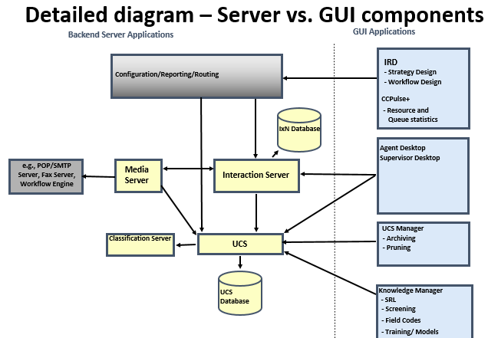

# Security in communication

**Versions supported (application dependent):**

* **TLS 1.1, TLS 1.0, SSL v3, SSL v2**

**Modes supported:**

* **simple (no need for client-side certificate)**
* **mutual (client-side certificate is required)**

**Supported Certificate and Key File Formats:**

* **X.509**
* **PKCS#8,12**

**Genesys generic TLS configuration steps**

To use Genesys TLS functionality, you must complete the following steps:

1. For UNIX, install the Security Pack on each host computer where Genesys components run.
2. Set up a Certificate Authority (CA) on all server and client hosts that will be using TLS. See Certificate Generation and Installation.
3. Create and install security certificates on UNIX and/or Windows platforms, as follows:

* For simple TLS, install the certificates on only those hosts with Server applications;
* For mutual TLS, install the certificates as follows:
* On those hosts on which the Server applications are running.
* On other hosts that are not running Server applications but are running Client applications.

4. Complete application-specific and/or host-specific configuration procedures in

GA / GAX / CME.

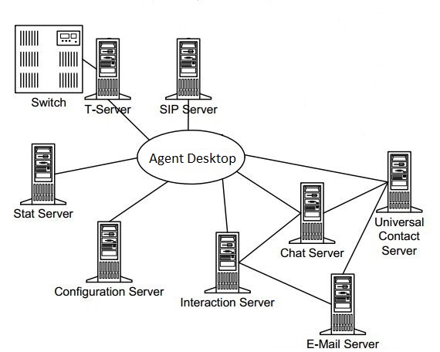

# Grocary

**Capaciti rule** - Логическое выражение, описывающее максимальное число interactions, для всех типов медиа, которые конкретный ресурс может захендлить. Для каждого типа медиа правило показывает границы способности агента получать интеракции этого типа. Влияют на распределение интеракций, не создание интеракций агентом, могут быть использованы для определения приоритетов медиа, не определяют, какие медиа типы агент может обрабатывать и логиниться(это в ролях), **только количество интеракций** в них конфигурируются для агента, плейса, или уровня тенанта. **Тенант** – **плейс** – агент.

**Capacity Model components**

Хранит rule – **configserver**!, позволяет привязывать их к конфиг обьектам

**Interaction server** – берет стату со стат сервера, provide agent login and media channel activation. Лицензия ставиться на агентские места. Нельзя залогиниться есди нету свободной лицензии. Отправляет стату на стат сервер.

**Agent Desktop**

* + Requests specific media types and controls agent state through login/logout, ready/not ready requests to Interaction Server

**Stat Server**

* + Determines the agent’s availability for interactions of a specific media type based on a capacity snapshot

Только один rule используется одномоментно.

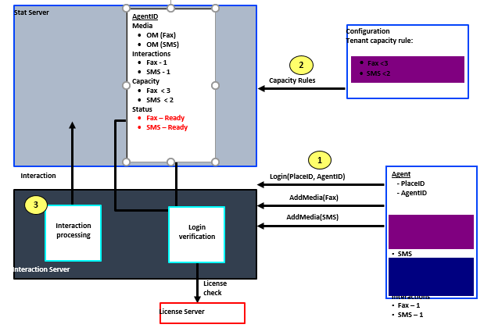

**Predefined Capacity Rules**

* **Default**

Стат сервер использует его, когда никакое rule не назначено агенту, тенанту, или плейсу в configLayer.

Правило не доступно в config layer и не редактируется, оно встроено в логику стат сервера.

Правило гласит, что агент может получить одну войсовую интеракцию, если не работает над интеракцией любого другого типа, агенты не могут получать е-мейл или чат.

**Predefined Capacity Rules**

**Default_One_interaction_of_any_type_only**Agents can handle no more than one interaction at any given moment of time, but the interaction can be of any media type. Maximum resource capacity is one interaction: one voice, or one e-mail, or one chat (and only these medias).

**Default_One_media_allows_more_than_one_interaction**Agents can handle none or one interaction of each type simultaneously, with the exception that the agent can handle up to five e-mail interactions when handling up to one interaction of other media types. Maximum resource capacity in this case is: one voice, plus one chat, plus five e-mail interactions.(можем дать для одной медиа более одной интеракции)

**Default_Voice_interactions_always_allowed**Voice interactions have priority over other types of interactions. An agent can handle one interaction of any type at any given moment of time, but if the interaction is not a voice interaction, the agent can handle a voice interaction in addition to the interaction currently being handled. Maximum resource capacity in this case is: one voice interaction, or, one chat and one voice interaction, or, one e-mail and one voice interaction. (войсовые складываются в очереди, имеют приоритет над другими)

**Capacity Snapshot**

Stat Server generates a new capacity snapshot for the agent each time a new agent state message is received

Стат сервер генирирует снапшот для агента каждый раз когда получается новый agent state

Снепшот содержит agent state и доступность по типам медиа.

URS использует снэпшот, предоставленный стат сервером во время роутинга.

Стат сервер автоматически обновляет agent capacity snapshot когда принимается новое capacity rule

Лог для капасити только на уровне – **all(по дефолту)**, trace.

**Queue vs queue view**

Queue –место, куда кладеться интеракция в процессе обработке. Интеракции submit из queue в стратегию через метод пуш

Queue view –отслеживает прохождение интеракиций, выходной порт из queue в стратегию, можно написать условие

**Virtual routing point –**присутсвуют в свичах – в dn-ах – непостоянные обьекты, нельзя создать или уничтожить, предназначены для того чтобы стратегию можно было использовать, чтобы интеракцию можно было конкретно привязать к пункту в бизнес процессу.

**Interaction Properties**

**How IBP works**

In general, like this:

* Interaction Server gets a new interaction from a Media Server and places it in a Queue
* The interaction is then taken out of the Queue and submitted to a Strategy
  + A Strategy performs the processing specified and eventually routes the interaction to a target (e.g., agent)
* The target processes the interaction and places it into another Queue where another Strategy may process it
  + For example, a Strategy may send an agent’s draft e-mail response to a Queue for Quality Assurance checking
  + The Queue/Strategy cycle continues until the interaction reaches some final (usually outbound) Queue and is stopped

Интеракция состоит из свойств, доступны как аттач дата(пара ключ - значение).Используются для управления интеракциями и межсерверного взаимодействия. Неоторые уникальны для итерация, некоторые обычны для всех. Свойства могут изменяться, могут использоваться для

Сегментирование

Приоритезация

Составление отчетов

Можно их увидеть: 1 Дэбаг медиа сервера, аттач дата, URS, IS, agent desktop, **cme\ga\ird –keys,**

**Sources of ixn properties**

* **Values for interaction properties are initially provided by a Media Server or agent application in RequestSubmit**
  + - **For example, the values for interaction id and interaction queue**
* **Some interaction properties are provided in the form of user data (key/value pairs)**
* **Next slides show server-by-server examples**

**How to change ixn properties**

* **Some properties can be changed by the party that handles an interaction, for example…**
  + **URS / ORS**
  + **An agent / supervisor desktop application**
  + **A Media Server**
* **The RequestChangeProperties request of the *Interaction Server protocol*\* is used for changing properties**
* **It supports changing, adding, or deleting properties**
* **If properties have been successfully changed, the client who requested the changes gets EventAck**
  + **All other clients of Interaction Server get EventPropertiesChanged which contains a list of changed/deleted properties**
* **If the interaction is being processed by URS, it gets EventAttachedDataChanged (*T-Server protocol\**) which contains all of the interaction properties**

**Categories of ixn properties**

**Interaction Properties are grouped in next categories:**

* + **System Properties**
* Maintained solely by IXN Server as independent fields in the Interactions table
  + The values of system properties cannot not be changed by a user (i.e., through IRD or CME / GA / GAX)
  + Values are changed automatically by Interaction Server based on client requests to manipulate interactions You can see system property names in debug-level logs
  + **Business Properties**
* Like system properties -
  + Also columns in the Interactions table
  + Can use these properties on the Condition and Order tabs of Views
* Unlike system properties, they may be changed by applications working with the interaction
  + - IRD, a Media Server, URS, or an Agent Desktop may set or update them according to the needs of the application
    - Many, once initially set, are simply read (remain static**)**
  + CategoryId
  + ContactId
  + CustomerSegment
  + DispositionCode
  + FromAddress
  + **Custom Properties**
  + Reserved as independent fields in the Interactions table with generic names such as CustomString3
  + Usage is not predefined
    - Available for you to define
  + Can be used the Condition and Order in Views
  + Are not altered by Interaction Server
  + Are controlled by apps working with the interaction
    - Media Server, Agent Desktop, URS
  + Usage Examples
    - Product Category
    - Social Security Number
  + **Flexible Properties**

**Key concepts – Interaction definition wrap up**

What is an interaction in the context of Multimedia?

* + It's a non-voice communication (successful or not) between a customer and a front or back-office worker, in either direction
  + It has a media type
  + It may give rise to other interactions (as when an incoming e-mail gives rise to an automatic acknowledgement)
  + It may belong to a series of related interactions, known as a thread
  + It's represented internally by Interaction Server as a software object with a unique id
  + It can serve as a parent to another interaction or be a child of an interaction When multiple interactions are threaded (related), a parent id is used to establish the thread

There are three protocols used by Multimedia:

* Multimedia Interaction Management protocol
* Multimedia Reporting protocol
* Different from the one used by other Genesys applications
* Some Interaction Management and Reporting Protocol events overlap
* A subset of Genesys T-Library events
* Used by Interaction Server to communicate with URS

Participants in protocol messaging:

* Interaction Server
* Media server (ESJ, Chat Server, or a custom Media Server)
* Agent application
* Routing Engine (URS or URS-ORS pair)

Reporting engine (Stat Server or Interaction Concentrator

**Flow Diagram**

* Flow diagrams provide a visual map of the messages that define an interaction, like logs

You cannot always generate all the needed log files to see models

* You do not always want to look at a log file - they can be large and unwieldy

ok

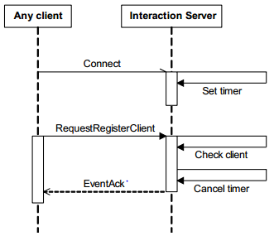

nok

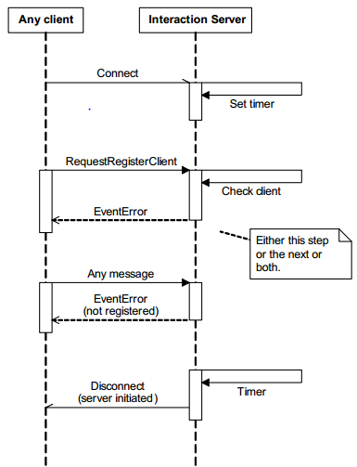

**Agent logs in**

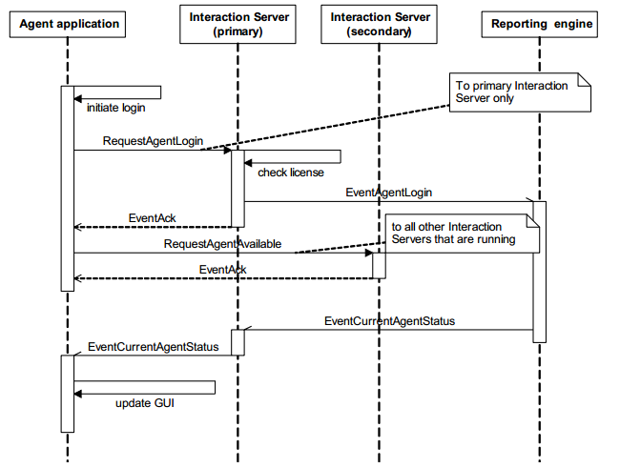

**Agent log out**

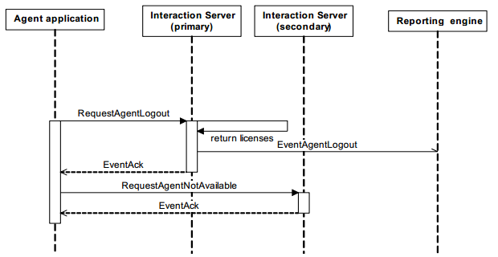

# REPORTING

## Real-time

Reporting solution = **Operational Reporting(CC Pulse+ CC Analyzer)**

Solution Reporting components gather information about contact center productivity and operations. viewing and analyzing contact center performance, enabling you to improve enterprise efficiency. It consists of two products. **CC Analyzer** and **CCPulse+,** which draw on much of the same data but provide different functional capabilities.

**Real-Time** resource and interaction в текущий момент времени(не более минуты)(the number of calls in queue, service level, and the number of agents logged in, redy/not, aftercallwork ….)

**Historical** reports on resources and interaction volume(such as a monthly service level or an agent's quarterly performance) Answers the questions of what happened yesterday, last week, month, quarter, and year.

**CCPulse+** allows you to track the real-time status of your contact center against an historical context so you can make changes to routing rules, staffing, resource utilization etc. to correct any problems you may see

requests statistics from Stat Server

**Может просто отобразить хисторикал данные!**

**Contact Center Analyzer (CC Analyzer)** on the other hand, is a purely historical reporting environment that allows you to generate canned reports based on pre-built layout templates and to design custom reports and custom metrics that meet the unique needs of your business. Берет из стат сервера, скидывает их в базу.

Whereas CCPulse+ answers questions such as "What's happening right now? This minute? In the last 60 minutes?", CC Analyzer answers questions about what happened yesterday, last week, month, quarter, year.

**Analytical Reporting –** собрать исторические данные, пересчитанные метрики, средние времена, периоды, не чистые данные, а посчитанная аналитика.

Info mart –процессит эти данные. Он собирает все данные про интеракции. Номера, аттач дата, dn…, делает из них аналитику

Interactive Insights – темплиты для 3-д пати, из любой бд вытаскивает данные и строит графики.

Advisors – в огромных контакт центрах, позволяет увидеть проблемы.

**Configuration Layer** provides information about configuration objects for which statistics are collected.

**Management Layer and User Interaction** Layer where you centrally manage Genesys applications via Genesys Administrator or Solution Control Interface.

**Services Layer** defines statistical parameters and provides the statistical information requested by CC Analyzer and CCPulse+. The Services Layer consists of Stat Server.(стат сервер)

**Media Layer,** the most important component of which is the Genesys T-Server. supplies T-Event information used by other Framework components, such as Stat Server, that then supply data to CC Analyzer and CCPulse+(создает и обслуживает обьекты звонка)

CCPulse+ connects to: 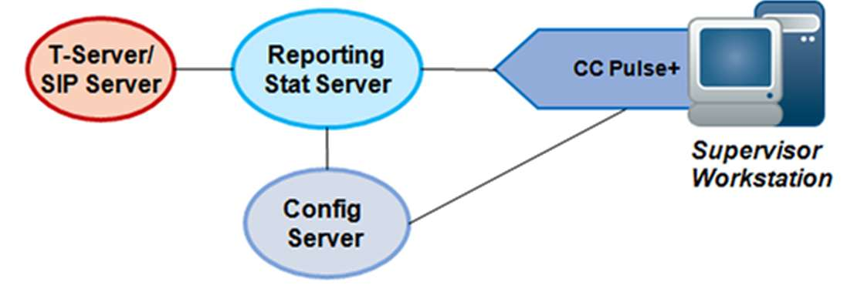

**Configuration** **Server** to get:

Information about configuration objects and available statistics

**Stat Server** to get:

Statistical values from which real-time reports are populated

**Data Flow**

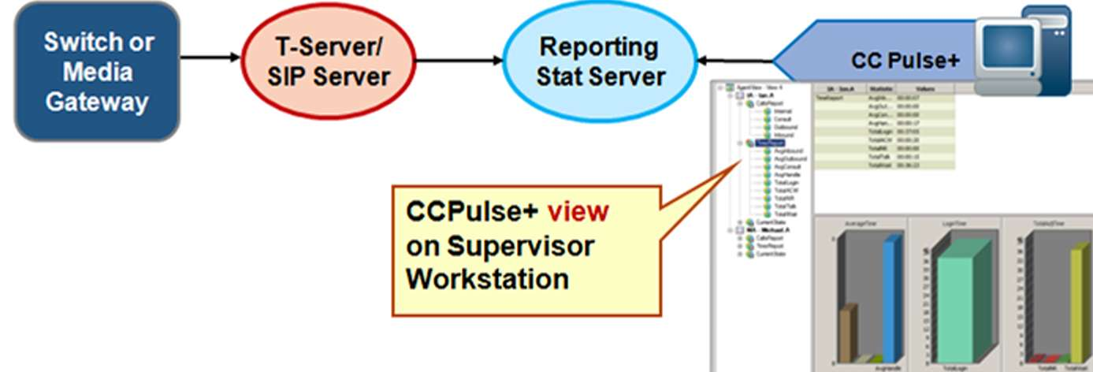

Real-time data flow for CCPulse+ reporting can be illustrated as follows:

- T-Server generates messages regarding switch activity and distributes them to its clients (including Stat Server). These are considered Event messages.

- Stat Server calculates statistics based on information from T-Server and generates messages about them.

- CCPulse+ requests statistics from Stat Server.

- Statistics are displayed in CCPulse+ views.

**CCPulse+ components**

**Workspace**

When you customize the look and contents of your CCPulse+ display, you create what is known as a *workspace.* It is during the process of creating a workspace that a specific Stat Server is chosen. You can choose a set of objects for monitoring, change the sizing and position of windows, and even change the colors displayed

**View**

. A view is the portion of the workspace that contains the selected objects, the statistics generated, and the table and graph display of the data. A view's attributes include the name of the template used to create the view, the objects selected for inclusion, and the position and size of the view's window

**CCPulse+ Storage Options**

Three storage types supported:

* + **Binary** and **XML** - Where each workspace, template, threshold, and action is stored in a separate file

**Legacy** - Provided for backward compatibility

Binary format template extensions:

* + Thresholds: *.bthr
  + Actions: *.bact
  + Temples: *.btpl
  + Workspaces: *.bwsp

**Ranks**

* + User:
    - Can apply predefined templates
    - Can open, close, and save existing workspaces
  + Administrator:
    - All User-level permissions
    - Can attach to Stat Servers defined in the Connections Tab of the CC Pulse+ object
    - Can use the following wizards:
      * Template
      * Threshold
      * Action
    - Can use the Import/Export Utility

## Historical

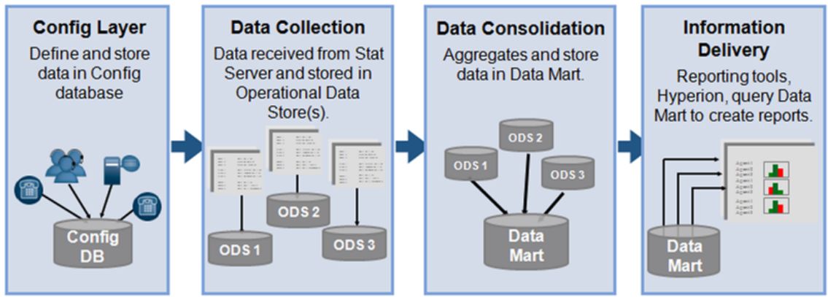

**Configuration Layer:** CC Analyzer's data collection components depend upon the Configuration Server to provide all object information

**Data Collection:** Data is retrieved from Stat Server and stored in a database called an Operational Data Store (ODS).

**Data Consolidation:** Data is transformed from any number of ODSs. aggregated, and stored in the Data Mart. Data Mart is the main database that warehouses data for all the contact centers of the business.

**Information Delivery:** Once the data is aggregated into a format that can be queried, a reporting tool such as Oracle Hyperion can be used to query the Data Mart and deliver reports.

**CcAnalyzer architecture**

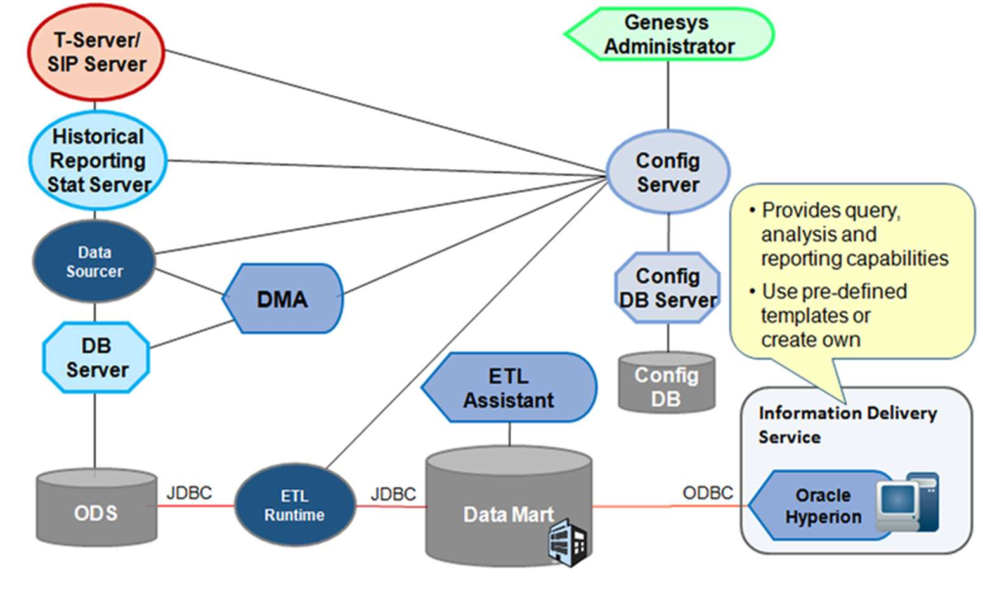

**Historical Reporting collects and presents information about contact center activities over long periods of time - weeks, months, and years. The primary sources of historical information are Stat Server and Configuration Server.**

**Data Sourcer** - Collects statistical data from Stat Server and writes it to ODS. It is a client of Configuration Server. Stat Server, and DB Server.

**(DMA)** enables you to use layout templates to choose which standard operational statistics to collect, on what objects, and how often**.** **DMA is a client of DB Server, Configuration Server, and Data Sourcer.**

**(ODS) - A relational database that serves as the staging area for the Data Mart Services.**

The components of a collection unit work together to collect and provide temporary storage for historical data until ETL Runtime (Extraction. Transformation, and Loading Runtime) transforms the data and transfers it to the Data Mart, the database where data is permanently housed. **ETL Runtime, ETL Assistant, and the Data Mart are the components of the Data Consolidation services.**

**• ETL Assistant - is the front-end interface you use to communicate with the ETL Runtime server. Using ETL Assistant, you:**

**Specify the ODSs from which ETL Runtime is to read data.**

**Establish a purge schedule for Data Mart elements.**

**Discover the names of the Data Mart tables to which data has been transferred.**

**Review Data Mart content.**

**• ETL Runtime is the workhorse of the Data Mart Services as it interacts with the following components to read, write, aggregate, and delete data: ODS, Configuration Server, ETL Assistant and Data Mart.**

**Stat server**

**Stat Server Functionality**

Stat Server tracks information for telephony events and object status (Agents, Agent Groups, and DNs), and then converts this data into statistical information used by other Genesys components. Clients of Stat Server subscribe to statistics and then poll by repeatedly making requests for current information.

**State** - Stat Server tracks current state information associated with contact center resources. For example, it tracks the current status of an agent indicating whether or not the agent is ready to receive an interaction.

**Totals** - Stat Server calculates totals for defined statistical types. It tracks the number of times an action occurs or the duration in a specific state. For example, it tracks the amount of time an agent is in a ready state. It can also track the number of times an agent became ready.

**Utilization** - Stat Server calculates information about how efficiently contact center resources are being used. The meaning of the number depends on how the statistical type has been defined. It may represent an accumulation, percentage, average, or a minimum or maximum. For example, Stat Server calculates statistics indicating how efficiently interactions are load balanced over multiple queues.

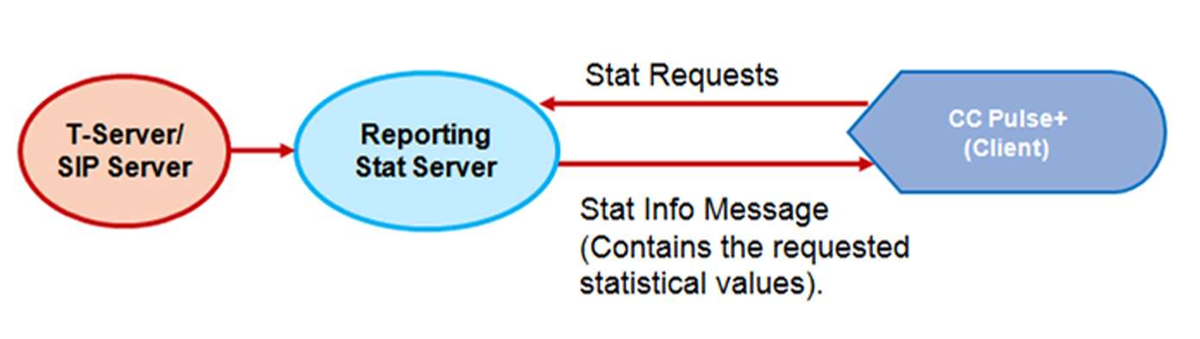

Stat Server as a Server

Stat Server supplies statistical information to client applications such as Universal Routing Server (URS). Data Sourcer. and CCPulse+ . To receive statistical information from Stat Server, its clients must specify what kind of information they need. As a server, Stat Server is responsible for processing client requests for updates on subscribed statistics

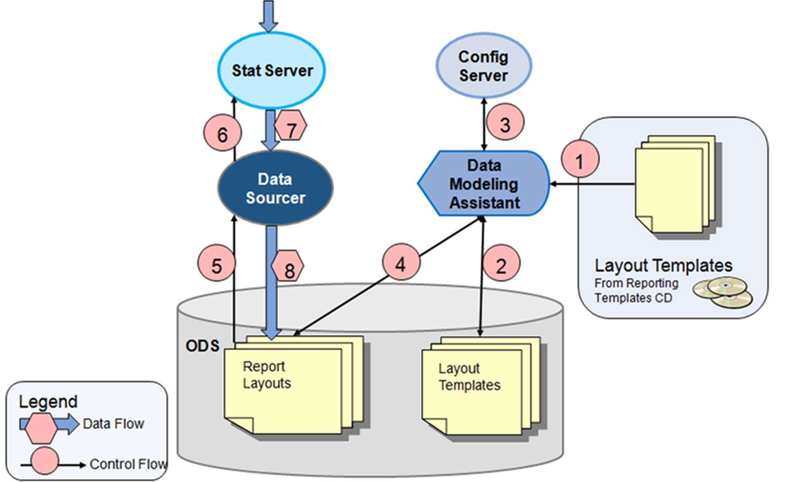

# What is a Genesvs Statistic?

A **Statistic** is a returned or calculated value of a **Metric** measured against configured Object (Agent Groups. Places, etc).

A **Metric** defines:

The kind of subject to be measured.

The characteristics of the subject to be measured.

How measuring is performed.

Metric defines not only what should be measured, but also where, how, and when it should be measured.

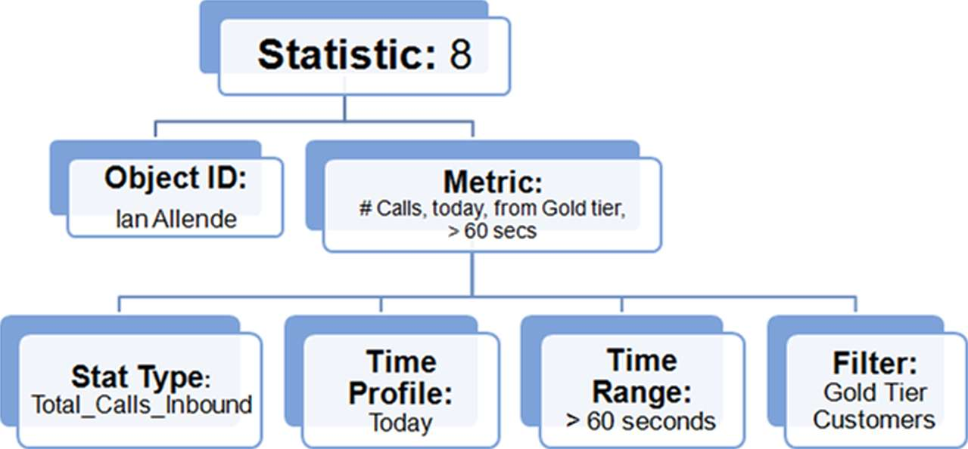

**TiME PROFILES**

**Growing Time Profile**

A Growing time profile resets the statistical value to zero at a specified time, using a 24-hour clock format. So the statistic is calculated "since midnight" or "since 8am." for example. Stat Server uses a special time profile, called Default, when Stat Server's client does not specify a time profile when requesting statistics.

**Sliding Time Profile**

A Sliding time profile does NOT have a start and end time but rather a sliding window defined in seconds. The number after the colon is the refresh rate (also in seconds).

**Selection Time Profile**

A Selection time profile is NOT based on time but rather the number of interactions. The example above will generate stats based on the last 100 calls. In other words, calculates a time interval defined by the end or occurrence of the specified number of actions or statuses.

**SinceLogin Time Profile**

A SinceLogin time profile resets statistics to zero (0) at the moment of agent login (their association to the place). Statistics continue to accumulate so long as an agent is associated with a specific place

1. Go to **Options** tab and locate the **TimeProfiles** section.

**TIME RANGES**

A time range acts like a filter to select only the actions which qualify. For an action to qualify, its *duration* must fall within the specified range. Examples: *0-20.*1*0-20.90-120,180-300 etc.*

**CurrentNumberInTimeRange**

**CurrentNumberInTimeRangePercentage**

**TotalTimeInTimeRange**

**TotalNumberInTimeRange**

**TotalNumberInTimeRangePercentage**

**ServiceFactorl**

**RelativeNumberPercentage**

**Use Cases:**

"How many callers abandoned after fewer than 30 seconds on hold?"

"How many calls were distributed between 1 and 2 minutes of arrival?"

"What percentage of an agent's calls last more than two minutes?"

FILTERS

Filters are used to 'filter in' (include) interactions based on specified criteria. In this way. they ensure that only those interactions meeting the defined criteria are tracked. Filters are configured in the Stat Server application Options, in a section called "Filters."

Value: PairExists("Lansua2e"."French")

Name: Chat

Value: MediaTvpe = 5

# ANALITIC

**ICON**

Interaction Concentrator is a Genesys product that collects and stores detailed data from

various sources in a contact center that utilizes Genesys software.

**The ICON server:**• Performs preprocessing of events received from Configuration Server, T-Server,

.• Prepares the data that will be stored in IDB. Writes the prepared data from the inmemory

queue to the persistent queue and persistent caches.

• Manages the data in the persistent queue and persistent caches.

• Writes data from the persistent queue into IDB.

• Writes data from the persistent cache for configuration data (**cfg-sync.db**) into IDB.

**Pq**- если разорван коннект с базой, занесет после восстановления. Вначале данные всегда ложаться в этот файл, лежит рядом с установленным айконом. Данные из pq вытаскиваются после шатдауна и рестарта, пока они оттуда не вылезут.

**Appstorage** – кэш для логин сессий

**Гайды/проги**

**Database** size estimator- считает сколько места нужно для бд. Зависит от количества интеракций, аттаченной даты… **DBMS** – о табличках

**Roles of icons**

ICON **cgf** ROLE – DN, person, place, skill (сfg)

ICON **voice** ROLE – для каждого сип сервера. (gcc,gud,gls)

ICON **multimedia** – с interaction server**(gcc,gud,gls)**

**Gls** – stores T/interaction servers data about agent state and agent login session

**Gcc –** interaction data

**Gud** – attached data, associated with calls

**Goc – outbound**

Default role = **all**

Each icon need database

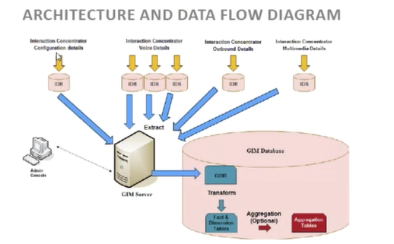

GIM – собирает, обьеденяет все собранные с айконов данные в интеракции, трансформ(переиваривает данные, ложит их в fact table), пурдж старых данных из базы . Сonnect to: scs, ms, cs, log4j java client, GIM admin console, **which**:

Display current etl job execution status, history of execution, execute job, cancel a scheduled job, shut down running job

Its main function is to run various functional jobs, including but not limited to ETL jobs. These jobs run according to the schedule that is configured in the Genesys Info Mart ETL application in Genesys Configuration Layer

**Dimentional data model(star schema):**

Daimention table - справочник по интеракциям, например войс, или оутбоунд …

Facts – links in daimentional table, and fact itself

• Aggregate — In deployments that include GI2 or the separately installed RAA

package, Genesys Info Mart also hosts the aggregation process. An aggregation job,

which is implemented as a plug-in, runs the aggregation engine inside the Genesys

Info Mart Server process, to calculate or recalculate the historical Aggregate tables in

the Info Mart database.

**GIM database** – contains all data populated by ETL job.

**Schema types:**

Control tables – indicate jobs status, history of run jobs

Merge tables – merge of interactions

GIDB tables – Merged interactions

Staging tables- in process of extract

Temporary tables - in transform process

GII- набор темплитов для построения репортов на основе данных из GIM

RAA – берет данные из из GIM базы, строит на основе сырых данных репортинг, подсчитывает суммы, метрики, агрегирует.

**JOBS**

• **Routine functions**—Genesys Info Mart provides jobs to perform the following

routine functions:

◦ Extract data from your source databases.

◦ Cleanse and transform the data.

◦ Load the data into the fact and dimension tables of the Info Mart dimensional

model.

◦ Optionally, calculate and load aggregated data into the Aggregate tables.

◦ Purge old data from the Info Mart database.

◦ Maintain calendar dimension tables.

◦ Add and delete partitions for partitioned tables.

• **Special-purpose functions**—Genesys Info Mart provides jobs to perform the

following special-purpose functions:

◦ Initialize the Info Mart database.

◦ Migrate your existing version 8.x Info Mart database so that it is ready for use

by the current 8.x release of Genesys Info Mart.

◦ In PostgreSQL deployments, perform supplementary database maintenance.

**Job_InitializeGIM -** *fill many of the dimension tables in the Info Mart database with fixed information., andautomatically executes the scripts to update IDB(s) for use with Genesys Info Mart.*

**Job_ExtractICON -** *Extracts new and changed records from one or more Interaction Databases (IDBs), and stores those records in Global Interaction Database (GIDB) tables in the GIM database.*

**Job_TransformGIM -** *Transforms and loads previously extracted data into*

*the fact and dimension tables of the Info Mart database.*_TransformGIM transforms the data that has beenextracted from all IDBs. GIM Serverlaunches this job during each ETL cycle after it hasextracted data from all IDBs. Job_TransformGIMtransforms GIDB data and then loads it into the InfoMart database as the last step of the transformation

process. **sending notifications about newly transformed factual data that is ready for aggregation**

**Job_AggregateGIM**

—*Aggregates or re-aggregates the facts based on data that was added or changed during the last transformation job. Stores the data in historical Aggregate tables.*

**Job_MaintainGIM**

—*Maintains the Info Mart database(Purging,* **Maintaining Calendar Tables, Maintaining Database Partitions***)*

**Job_MigrateGIM**

—*Runs all scripts and makes any other updatesnecessary to prepare your Info Mart database for thenew release of Genesys Info Mart, and automaticallyexecutes the scripts to update IDB(s) for use with Genesys Info Mart, if required.*

2. Which is the application provides access to the Configuration Database?

(Configuration Server)

4. Which is the application provides possibility of host monitoring?

(Local Control Agent)

5. Message Server functions

(Message Server provides centralized processing and storage of every application's maintenance events)

6. Configuration Manager is

(the Genesys software application that enables you to manipulate your contact center's configuration data and set user permissions for solution functions and data)

7. Genesys Administrator is

(a Web-based product that that replaces Configuration Manager and Solution Control Interface. GA simplifies operationmanagement with the ability to provision, deploy, and monitor all Genesys applications)

8. Alarm Conditions

(Alarm Conditions specify the events that you might want to know about and manage as soon as they occur)

9. Scripts

(Scripts identify processing scenarios or treatments that can be applied to customer interactions)

10. Application Templates

(An Application Template is the model you use for registering a new application in the Configuration Database)

11. Applications

(Applications are the various Genesys software programs that serve the contact center)

13. Solutions

(Solutions are sets of applications that accomplish particular business tasks in contact centers)

14. Tenants

(Tenants are businesses whose customer interactions are enabled or enhanced through services offered by a third party, typically a telecommunications service provider)

17. Switching Offices

(Switching Offices are the actual telephone switches that provide telephone service to contact centers)

18. Agent Logins

(Agent Logins are unique codes defined within a Switch and assigned to agents)

19. Dns

(Dns are communication devices, uniquely identified by their directory numbers, where customer interactions reside and are handled)

25. Access Groups

(Access Groups are groups of Users who need to have the same set of permissions for Configuration Database objects)

26. Roles

(Role objects define the task-level privileges that can be granted to Users and Access Groups as role privileges)

RM – resource manager

GVP RS – reporting server

MCP – media call platform

CCP – call control platform

FM – fetching module

**Deployment: mandatory components**Sip server (primary and backup?),Resource manager , reporting server, media control platform**Additional –** call control platform, policy server, snmp master agent

Direct Inward Dialing (**DID**). DIDs are obtained from the Dialed Number Identification Service (DNIS).

GVP uses IVR Profiles, which are VoiceXML, CCXML, Announcement, and Conference applications, to control interactions that require the use of Direct Inward Dialing (DID) numbers and provides service for the resources that use them

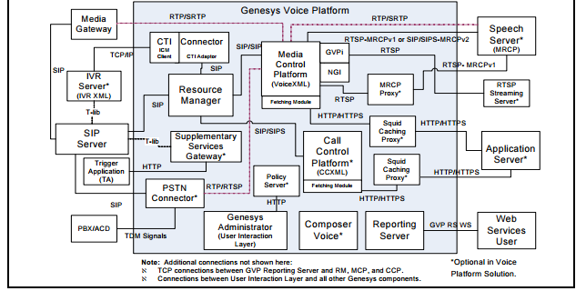

**Resource Manager**

The Resource Manager controls access and routing to all resources in a GVP. interacts with the Configuration Server to determine the (IVR) Profile, VoiceXML, CCXML, Announcement, and Conference application, and service profile required to deliver the service. The Resource Manager performs the following key roles in a GVP deployment—SIP Proxy, SIP Registrar, and SIP Notifier.

**SIP Proxy**

The Resource Manager resides between all SIP resources within the GVP system architecture. It acts as a proxy for SIP traffic between any two SIP components.

**SIP Registrar**

The Resource Manager acts as a registrar for GVP resources; however, it accepts registration only from those resources that are added to the Connections section of the Resource Manager Application object. Registration occurs through SIP REGISTER messages;

**SIP Notifier**

The Resource Manager acts as a notifier, accepting SIP SUBSCRIBE requests from SIP Server and maintaining multiple independent subscriptions for the same or different SIP devices.

**Resource Manager Functions**

* **Resource management** allocates and monitors SIP resources to maintain a current status of the resources within a GVP deployment. The Resource Manager provides load balancing and high availability for each resource type, as the workload is evenly distributed among resources of the same type
* **Session management** RM combines two logical functions of session management

**Physical resource management** - monitors the status of the various GVP resources and, based on request-for-service and capability mapping, routes to other resources that offer a particular set of capabilities or services.

**Logical service management**— applies and business logic to select the service that is delivered and the parameters that are applied. This means that the resource to fulfill the service does not need to be specified in advance.

* **Service selection**—When a call session arrives at the Resource Manager, the Resource Manager maps the call to an IVR Profile and, if applicable, to a tenant, and selects a service for the request.

**Two ways** in which RM determines which IVR Profile to execute:

**(DNIS) mapped to the IVR Profile**—GVP uses the DNIS to identify which application to run.

**Another Genesys component** acts as a master and executes a number of slave applications on GVP.

* **Resource selection**—After the Resource Manager has identified an IVR Profile and service type, it identifies a Resource Group that can provide the service.

**Policy Server**

The Policy Server component validates and resolves GVP-specific business rules (the policies that are enforced by the Resource Manager) and provides this information to Genesys Administrator in response to HTTP queries.

Policy Server Functions

• Manages DID ranges (newly created and existing) within the deployment by checking for overlaps.

**CTI Connector**

The CTI Connector **supports two modes** of CTI deployments—Genesys CTI and Cisco CTI integration. In both the deployment, the CTI Connector offers functions, such as the ability to obtain call related information (for example, ANI, DNIS), read or attach call data, play treatments to the caller, and transfer the call to the agent.

The CTI Connector acts as a SIP B2B UA to provide a SIP interface to the GVP components and it communicates with CTI by using the following protocols and interfaces: • XML over TCP/IP with Genesys IVR Server • GED-125 interface over TCP/IP with Cisco ICM.

**PSTN Connector**

The PSTN Connector is a stand-alone component that provides connectivity to traditional telephony networks and equipment, such as a private branch exchange (PBX) or automatic call distribution (ACD) . For existing deployments that use Dialogic TDM cards, the PSTN Connector provides seamless integration and migration to the IP-based GVP. **The PSTN Connector acts as** a media gateway by using Dialogic boards to interface with the TDM side of the network and translate TDM calls to SIP calls so they can be handled by SIP Server and the GVP components.

PSTN Connector Interfaces The PSTN Connector provides interfaces to support the following three signaling protocols:

1. Integrated Services Digital Network (ISDN)—Comprised of digital telephony and data-transport services offered by regional telephone carriers. ISDN uses digitization to transmit voice, data, text, graphics, music, video, and other source material over existing telephone wires.

2. Robbed-bit signaling (RBS)—A specific type of Channel Associated Signaling (CAS), which robs the least significant bit of information in a T1 signal from the channels that carry voice and uses it to transmit framing and clocking information. 58 Genesys Voice Platform 8.1 Chapter 2: GVP Architecture GVP Components

3. CAS for channelized E1 lines—Commonly used in Latin America, Asia, and Europe and is configured to support channel banks in the network that convert various battery and ground operations on analog lines into signaling bits, which are forwarded over digital lines.

**Reporting Server**

The Reporting Server receives data from the MCP for VoiceXML applications, from the CCP for CCXML applications, and from other components involved in servicing a call, such as the RM.

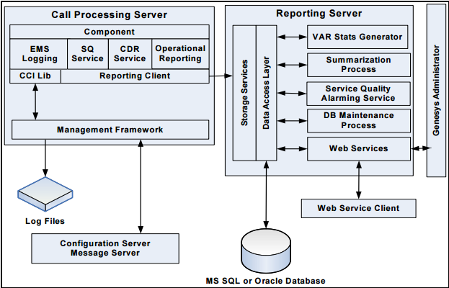

**GVP Logging**

• Each component, or GVP Application object, uses a GVP Logging interface to emit call and logging events that are related to component activity and to route the logs to one or more log sinks.

**Call Detail Record** (CDR) Service, through which the components submit CDRs that contain specific call information—such as start time, end time, and the IVR Profile and tenant that are associated with the call—to the Reporting Server.

**OR Service** Operational Reporting Service, which accumulates call arrival and call peak statistics. (These statistics are applicable for the Resource Manager, Media Control Platform, and Call Control Platform.)

**The Reporting Server** stores and summarizes data and statistics that are submitted from the Reporting Clients on the call-processing servers, to provide 5-minute, 30-minute, hourly, daily, weekly, and monthly reports. The Reporting Server manages the following types of data: υ Call-detail records υ Call events υ Call arrival and peak data υ Usage-per-IVR Profile data υ Usage-per-tenant data υ Service-quality (SQ) summary statistics υ SQ latency histograms υ VAR summary statistics

**Service Quality (SQ)** Reporting Service, in which the Media Control Platform generates INFO-level logs that are used by the Reporting Server to generate SQ and latency calculations and call-tracking information.

**A Reporting Client** on each call-processing component is responsible for reliable delivery of accumulated data to the Reporting Server. In GVP 8.1, the data is transported over TCP

**Лекция 2**

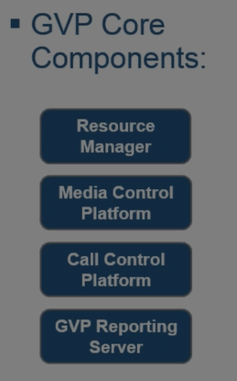

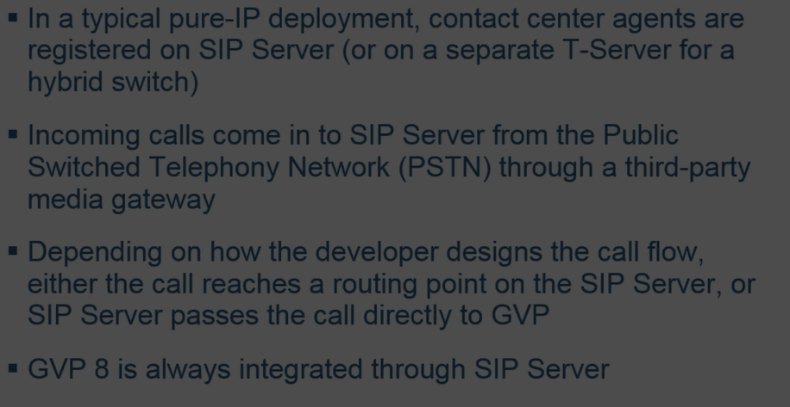

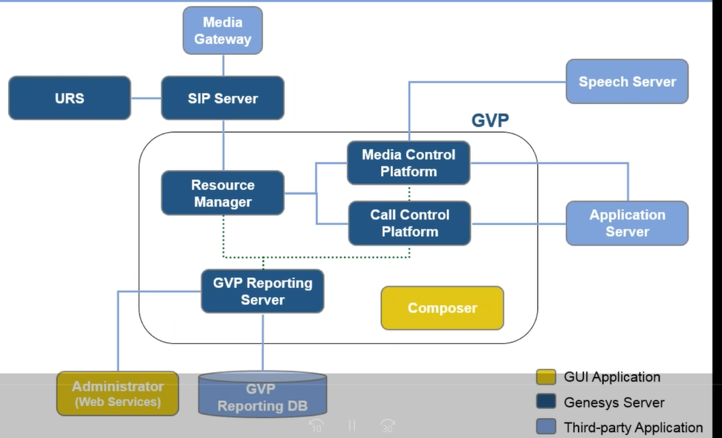

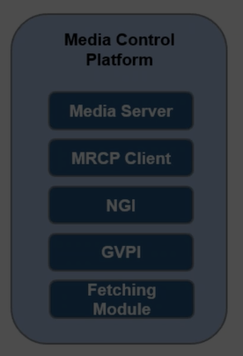**Media control platform consist of:**

* **Media server** (for media processing).Group of libraries -

**Audio/Video encoding**(g.711,22,26)/ h264

**Rtp support, file container support**

**Call recording**

* **MRCP client** – for integration with speech engine(text-2-speech, speech recognition), using mrcp protocol.

**MCP**: Include 2 interpreters , which request voice xml pages from web application server , compile and execute them. Both installed by default, but ngi more cool.

* **NGI** - next generation (for voicexml),Dll, that run in process in the MCP default for mcp. Allow to use json format, integrated with composer
* **GVPI** – legacy gvp interpreter(voiceXML and TeleraXML). Default for gvp v7.6, windows only, also Dll

**Media Control Platform Functions**: • Initiates outbound calls • Handles network-initiated call disconnections • Supports VoiceXML applications • Plays audio, video • Streams TTS, audio, and video • Records audio and video • Supports dual audio channel and dual video channel call recordings • Collects call recordings • Performs ASR and dual tone multi-frequency (DTMF) input handling (barge-in or non-barge-in) • Streams audio data to an ASR server for speech recognition • Transfers calls • Conference calls that use audio and video, and support an unlimited number of participants

Call control platform

The Call Control Platform is an optional GVP component that is required only for configurations that use CCXML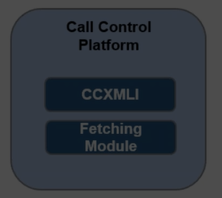

**Core exe file**

**Ccxml** - Call control XML interpreter. CCXML designed to provide call control support for telephony operations:

call handling and control

* Multi parted conferencing

**Functions:** Initiates conferencing. • Initiates VoiceXML dialogs on the Media Control Platform through the Resource Manager. • Creates outbound calls through an IP/Public Switched Telephone Network (PSTN) gateway.

**Call flow**

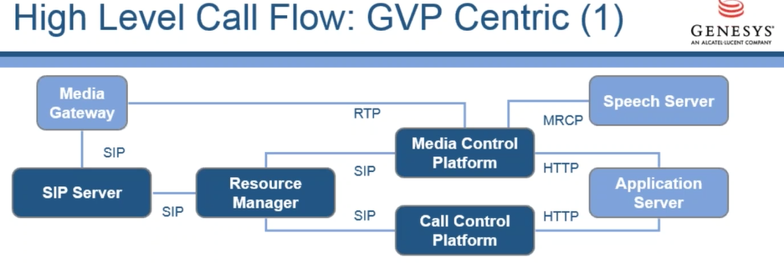

1. Call placed in sip gateway and gateway configured to forward calls to SIP server.
2. Media gateway and/or softswitch communicates signaling throught SIP
3. SIP server communicates signaling with resource manager (SIP invite)

Resource manager decide what to do with call based on configuration. (IVR profile and tenant settings)

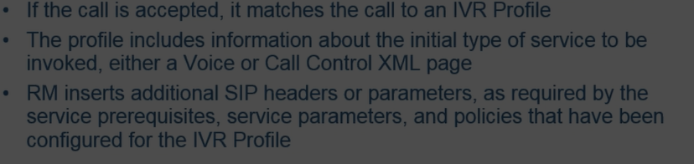

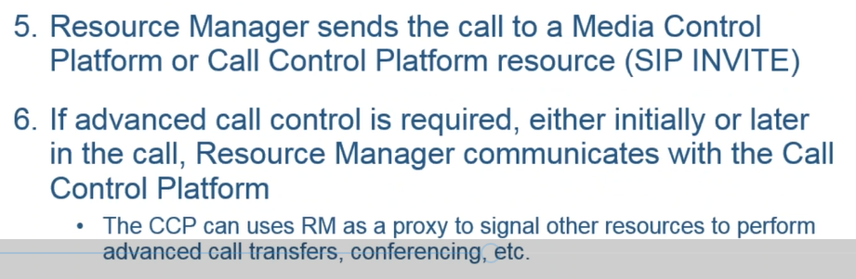

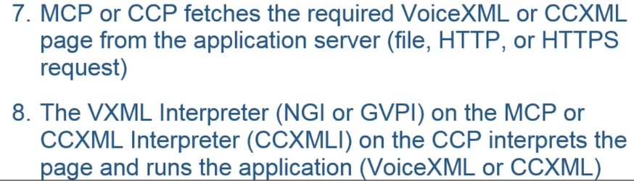

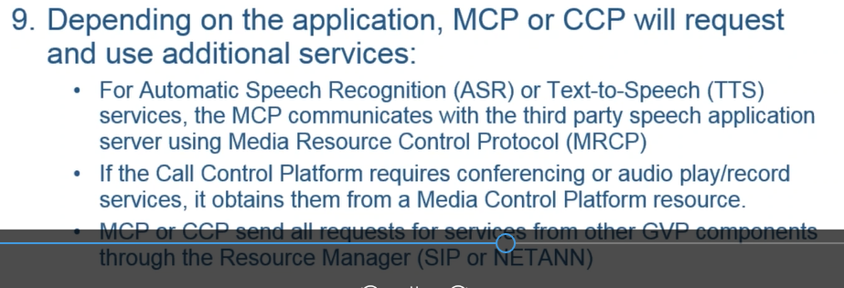

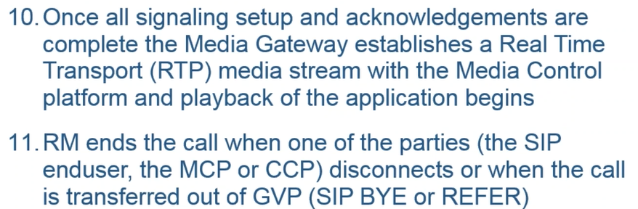

**HAresources**

**RM hight availability**

* 2 RM combined in HA pair with a common virtual IP
* Possible modes : active – standby,

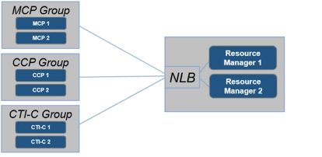

* active – active.

**ServiceHA**

-Several instances of mcp can be installed

**Sip serverHA**

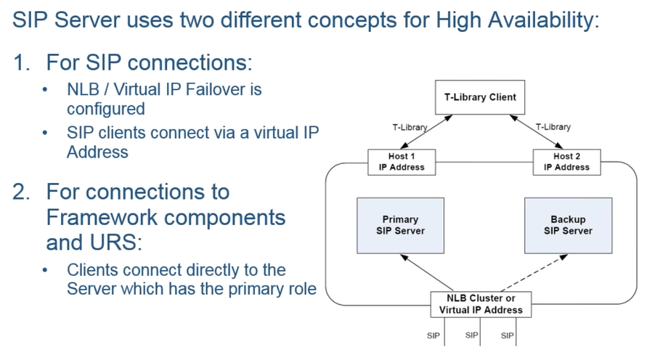

**ReporingHA**

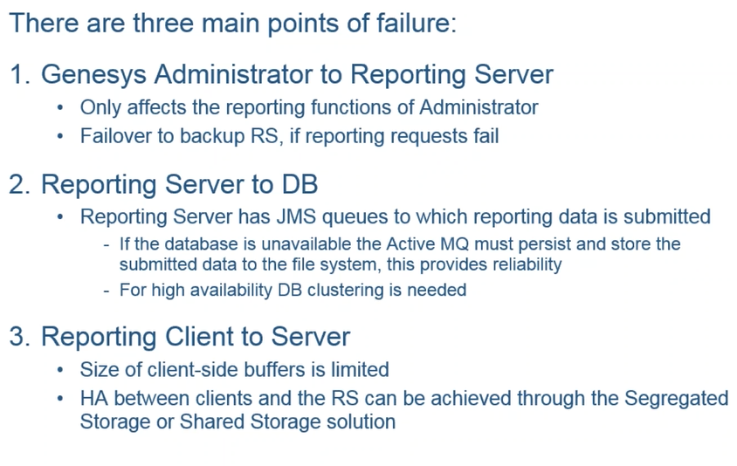

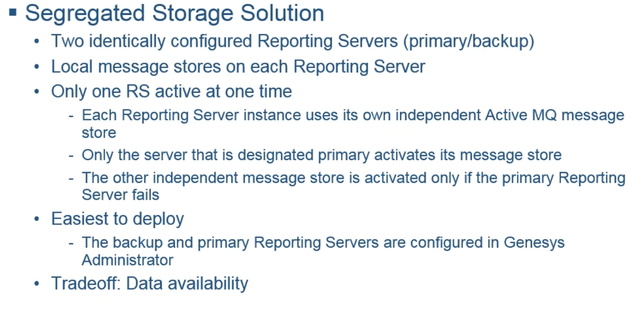

**DeploymentIntegration**

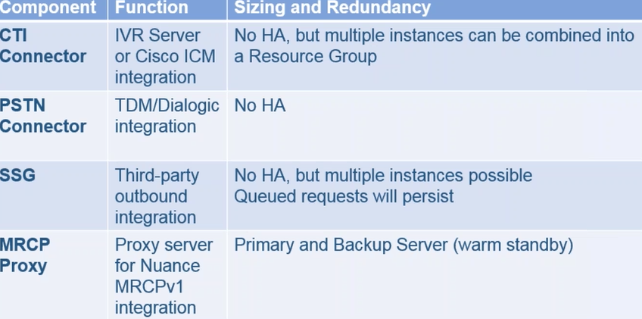

**HA3-dparty**

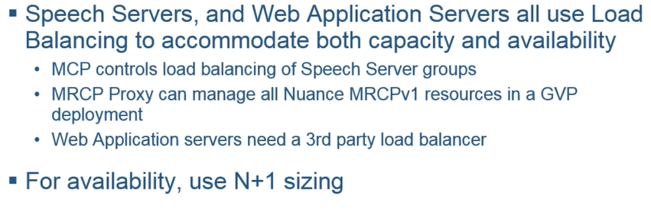

**Squid**

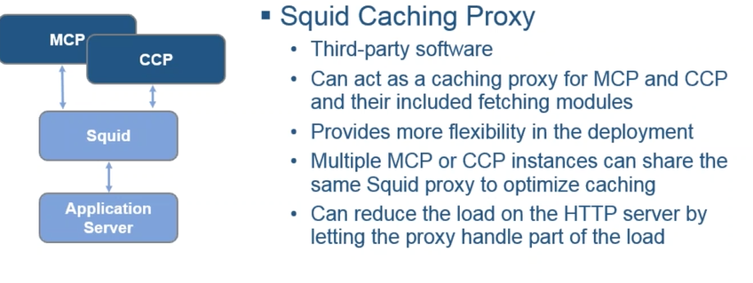

**Capacity performance:**

